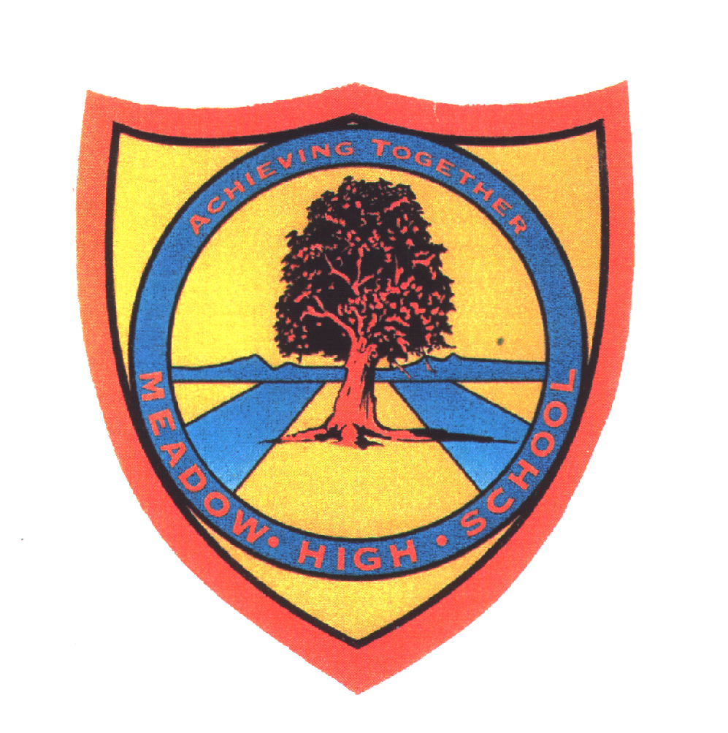 | Pathway 1 | KS4 Cycle 1 | Autumn 2  Topic: Forces
Learning Intention: For pupils to learn about types of forces such as gravity, friction, water resistance and air resistance.
Key knowledge that should be learned during this SoW |  | All | Most | Some
Concept: |  | Pupils will explore gravity, friction, water and air resistance. They will learn about scientific theories and use their knowledge to investigate, plan and predict.
Knowledge: |  | To explore gravity  To consider what will happen | To be able to identify different forces acting on objects  To Newton and gravity.  Explore Galileo’s ‘Tower of Pisa’ | To be able to identify and explain the different forces acting on objects.  To explain Newton’s role in discovering gravity.  Understand the forces reacted to Galileo’s ‘Tower of Pisa’
Key Skills: |  | Observing  Measuring  Identifying  Investigating | Measuring  Designing | Maker conclusions.
Curricular Links |  | History, speaking and listening, geography

