Meadow High School
Royal Lane, Hillingdon, Middlesex UB8 3QU

Telephone: (01895) 443310
Email: meadow@meadowhighschool.org
Website: www.meadowhighschool.org

Headteacher: Mrs Jenny Rigby
Deputy Headteacher: Ms Claire Caddell
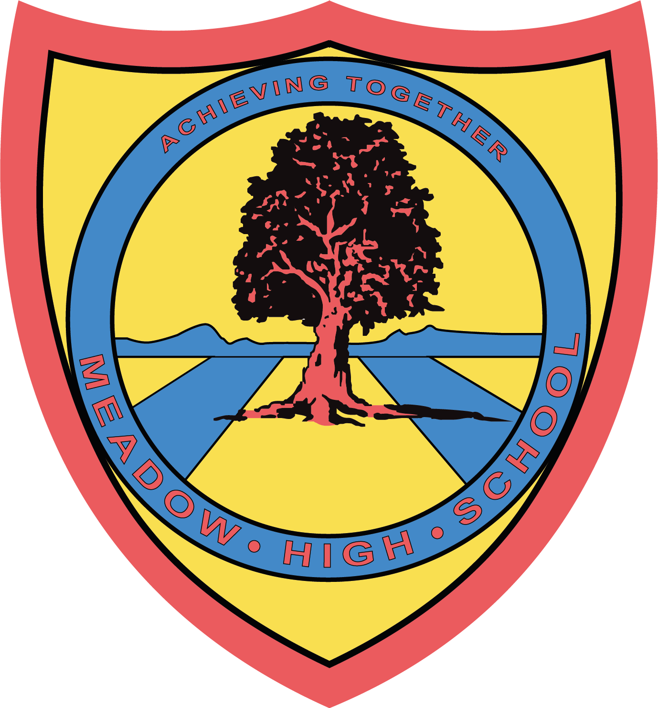

Wednesday 24th May 2023

Dear Parents/Carers,

End of Year Trip to Airport Bowl and McDonalds - Tuesday 4th July 2023.

As an end of year social trip, we have organised a visit to Airport Bowl and McDonalds on the Bath Road.

We will be leaving school after break at 11.30 and returning to school at 2.30pm in time for normal transport home. We will be travelling by minibus, which will be driven by a MIDAS (qualified) trained driver, first aiders will also accompany us.

There is no cost for this trip, although we still require reply slips. In addition, your child will not need to bring a packed lunch on that day.

I hope that your child will be able to take part in this trip, as it is designed to support our interventions. Please complete the attached slip and return it as soon as possible. If you have any enquiries, please feel free to contact me.

Thank you in advance for your help and support.

Yours faithfully,

Miss L Barratt Miss R Barham
Inclusion Lead and Designated Teacher for Looked After Children Interventions Teaching Assistant

Article 23:- 'A child with a disability has the right to live a full and decent life with dignity and independence, and to play an active part in the community.'



✂-------------------------------------------------------------------------------------------------------------------------------------------------
REPLY-SLIP: End of Year Trip to Airport Bowl and McDonalds - please return to Miss Barratt or Miss Barham

I am aware that my child………………………………………………………………………….has a trip to Airport Bowl and McDonalds on Tuesday 4th July 2023.

Signed (Parents/Carer): ……………………………………………………………….. Date: …………………………

