Meadow High School
Royal Lane, Hillingdon, Middlesex UB8 3QU

Telephone: (01895) 443310
Email: meadow@meadowhighschool.org
Website: www.meadowhighschool.org

Headteacher: Mrs Jenny Rigby
Deputy Headteacher: Ms Claire Caddell
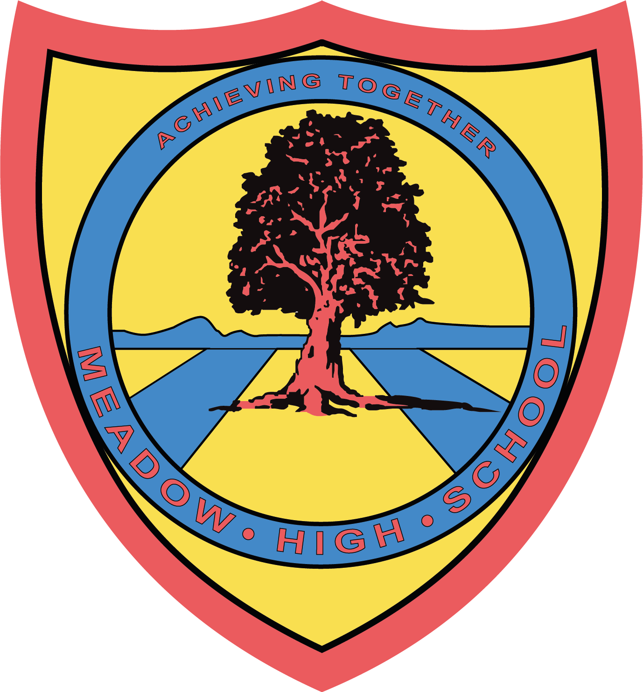

4th October 2023

Dear Parents/ Carers,

Sports Leaders – School Visit

As part of your child’s Sports Leaders course, your child will be assisting with a coaching session on Wednesday 18th October. The event will be taking place between 09:00 – 11:30 so no extra travel arrangements need to be made. Pupils will also be back for lunch on time. On the day your child should come into school in their PE kit.

If you have any questions just let me know.

Kind regards,

Mr. Anstee
PE Faculty Lead

Article 23:- 'A child with a disability has the right to live a full and decent life with dignity and independence, and to play an active part in the community.'



