Meadow High School
Royal Lane, Hillingdon, Middlesex UB8 3QU

Telephone: (01895) 443310
Email: meadow@meadowhighschool.org
Website: www.meadowhighschool.org

Headteacher: Mrs Jenny Rigby
Deputy Headteacher: Ms Claire Caddell
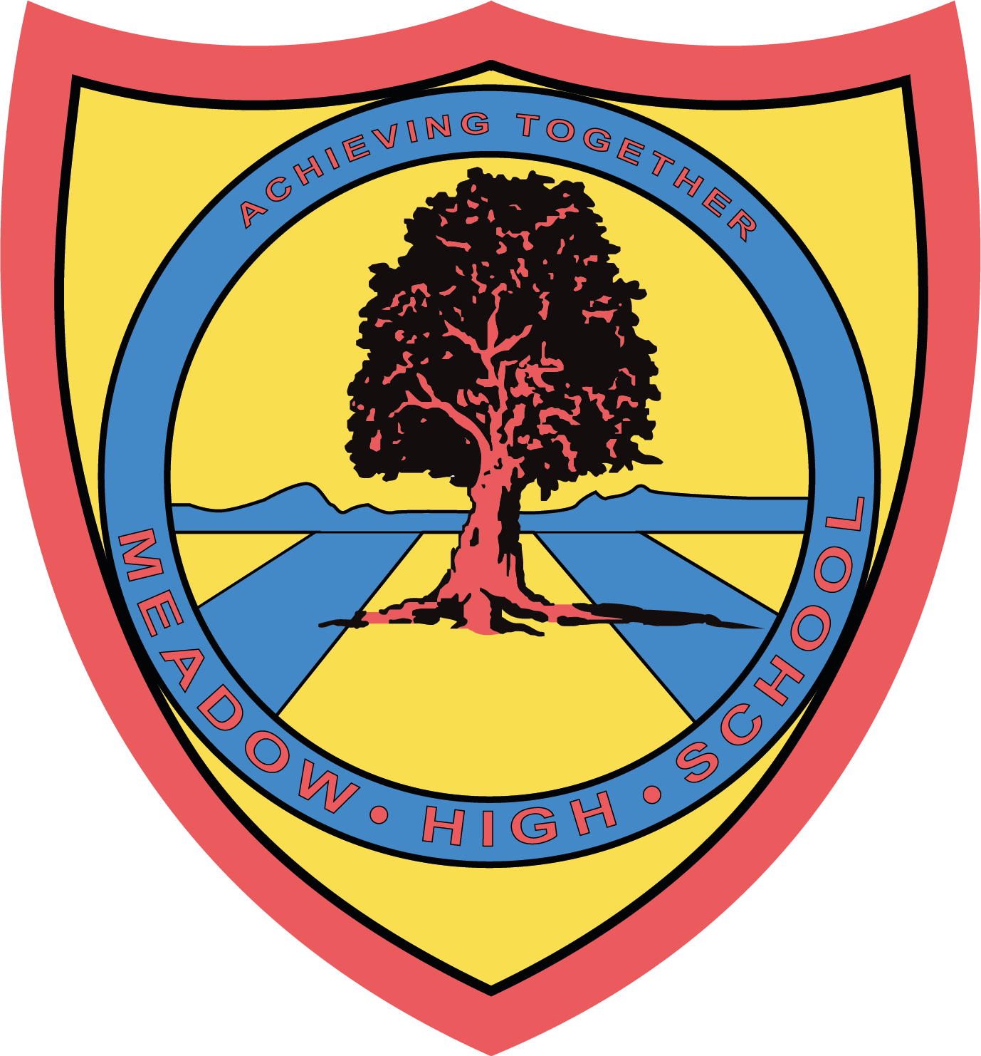

22nd November 2022

Arts Winter Workshop
Year 7
Dear Parents/Carers,

We are excited to inform you that your child will be taking part in our Arts Winter workshop on Friday 2nd December 2022.

If you would like to come along and participate in your child’s learning activities, please return the reply slip to Miss Kepinska by Friday 25th November. We have availability for a maximum of 2 places per family.

The clothes theme for this year is a white, red or green top, or alternatively a Christmas jumper and dark trousers, any seasonal headgear is also welcome. Please can you make sure your child brings in their chosen top with them on the day and hand it to their Form Tutor to look after until break time, alternatively they can wear their school jumper.

Please be aware that we have no parking on site, apart from a limited number of visitor spaces (in the parking lay-by, where the coaches pick up and drop off the pupils, directly in front of the school).
Please do not park in the staff allocated parking bays, please use alternative transport or park in alternative locations, as places are very limited.

We invite you to arrive between 11:00 am and 11:15 am. The workshop will start promptly at 11:25 am and we ask parents to kindly vacate the premises no later than 12:25 pm at the end of the workshop.

We look forward to you joining us for a fun session with a range of seasonal Art and Crafts, some Performing Arts Games and Christmas Carols.

Yours sincerely,

Miss Kepinska
Arts Faculty Leader

__ ___ ___ ___ ____ ___ ___ ___ ____ ______ ____ ___ ____ ___ ___ ___ __

REPLY SLIP - Arts Winter Workshop- Year 7- Please return to Miss Kepinska

Please RSVP by Friday 25th November 2022

Parent/Carer Name [please print]: ___________________________________________

Child’s Name [please print]: ________________________________________________

Class____________________

Please indicate if you will be attending the Year 7 Arts Workshop on Friday 2nd December at 11:25am

Yes, I will be attending and need only 1 place
Yes, we will be attending and need 2 places
No, unfortunately I/we will not be able to attend

My child will bring in a ______________ coloured top for the Form Tutor to look after.

Signed: __________________________________ Date: ___________

