Meadow High School
Royal Lane, Hillingdon, Middlesex UB8 3QU

Telephone: (01895) 443310
Email: meadow@meadowhighschool.org
Website: www.meadowhighschool.org

Headteacher: Mrs Jenny Rigby
Deputy Headteacher PW2/3: Ms Claire Caddell
Deputy Headteacher PW1: Miss Amy Willis
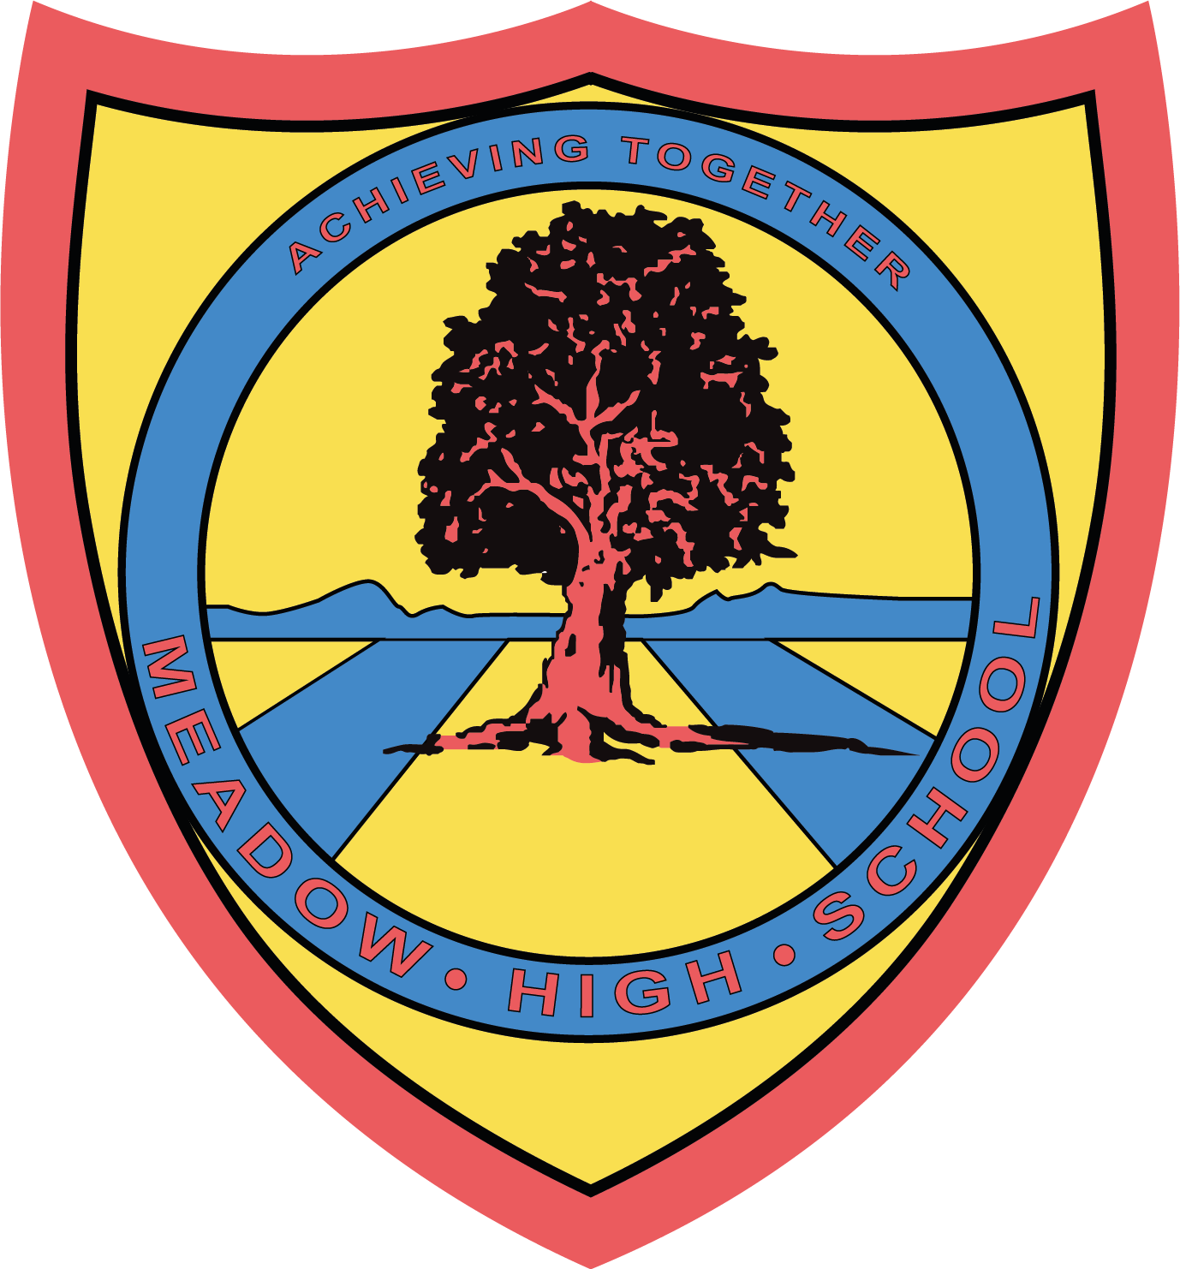

22 November 2023

Dear Parents/Carers,

The Big Breakfast 2023

We are pleased to announce our annual Big Breakfast will be held on Thursday 21st December. This will consist of an Egg, Bacon, Sausage Roll, Baked Beans and Toast (vegetarian option available) at the cost of £2.20.

The Big Breakfast will commence from 9.00am onwards and will replace the normal breakfast club arrangements.

Please can you return the reply slip below by Friday 15th December, so that we can have an idea of the expected numbers in advance. Payment must be made via your child’s ParentPay account. If you have not yet activated an account please contact the school Reception for information.

Yours sincerely,

Jenny Rigby
Headteacher

___________________________________________________________________________
Reply Slip- The Big Breakfast – Please return to reception

Childs Name:_________________________ Class:____________

Please tick appropriate box  :

My child wishes to have a Big Breakfast

Meat Option

Vegetarian Option

Payment of £2.20 has been made via ParentPay

Signed _____________________________ (Parent/Carer)

