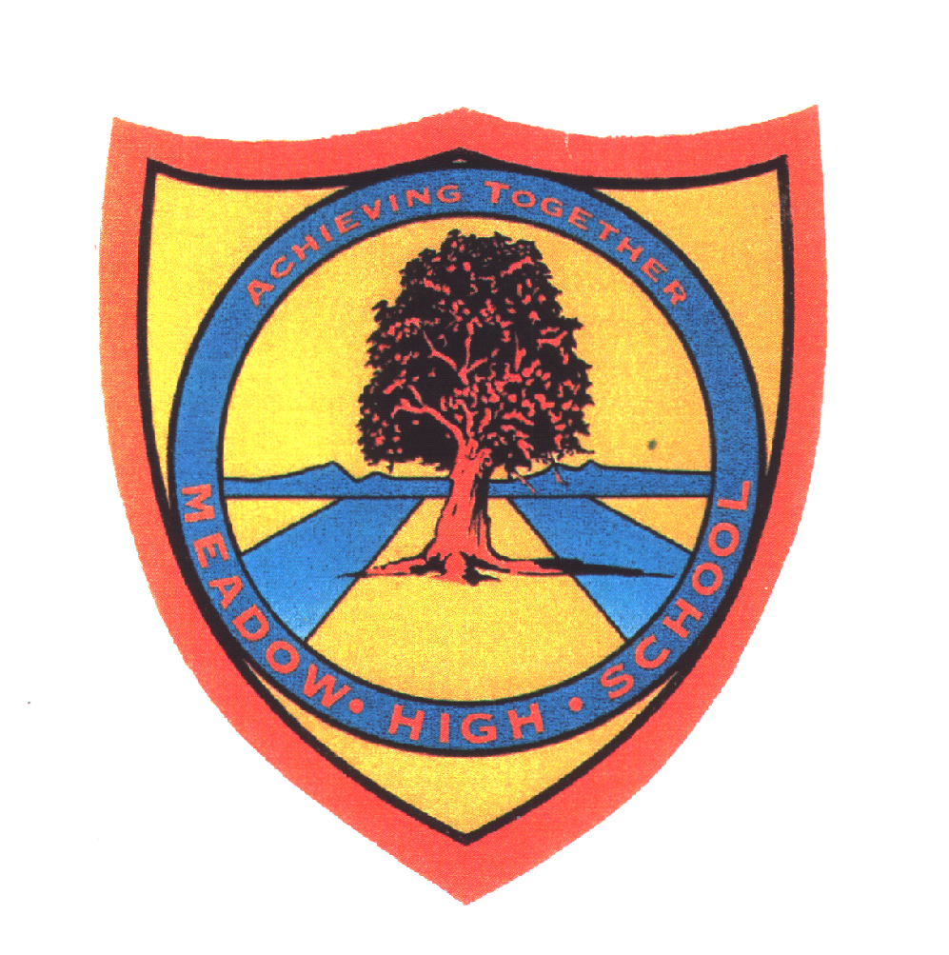 | Pathway  ‘2-3’ | Year 8.1 Music | Autumn Term 1 up to Spring half Term of Term 2
Learning Intention: Music & Songs from different Countries & Cultures
This unit explores music from different countries and cultures. Students will have the opportunity to learn about a traditional East African Song and learn to sing in Swahili, they will learn notation for the Pentatonic scale and learn to play Chinese songs as well as music from the West, American Pop-music using the keyboard. The purpose is to provide pupils with the opportunity to explore Music and songs from a variety of countries and cultures. Pupils learn to sing and appreciate different sounds, lyrics, scales and qualities of these songs and also learn to explore their language and communication skills.
Key knowledge that should be learned during this SoW |  | All (Pathway 2) | Most (Pathway 3) | Some (Pathway 4)
Concept: |  | To encourage and support pupils to:  - To develop an understanding of songs from different countries. | To encourage greater independence and decisions making through guidance in:  - To develop an understanding of songs from different countries and be able to express their favourite one. | To develop independent thinking, decision making, basic leadership skills and problem solving in group work by:  - To develop an understanding of songs from different countries and be able to express their favourite one, saying why they have made that choice.
Knowledge: |  | Develop a basic understanding of the following Core Knowledge:  - To be aware that music from around the world sounds different. | Develop a competent understanding of the following Core Knowledge:  - To be aware that music from around the world sounds different and that music can follow a tradition. | Develop a confident understanding of the following Core Knowledge:  - To be aware that music from different countries is different from Western music because of factors such as culture, instruments and beliefs.
Key Skills: |  | what will they actually be able to do as a result of this learning  -To be able to sing a song in Kiswahili  - To play a piece of music from a different country with some support.  -To compose a Chinese style song with regular support | what will they actually be able to do as a result of this learning  -To be able to sing a song in tune in Kiswahili  -To be able to play 1- 2 pieces of music from different countries with some support.  -To compose a Chinese style song with some support | what will they actually be able to do as a result of this learning  -To be able to sing a song in tune and in time in Kiswahili  -To be able to play 2 pieces of music from different countries with minimal support.  -To compose a Chinese style song mostly independently
Language and/or communication skills: |  | To develop confidence in subject related language and begin to use a range from the following keywords independently and mostly accurately sharing ideas verbally when prompted.  - Culture  - Country  - Singing  - Happy  - Africa  - China  - America | To improve use of subject related language and appropriate application of the below keywords and to share a range of new descriptions and their own keywords with the class:  - Culture  - Traditions  - East African  - Chinese  - American  - Scale | To explore use of subject related language using broad and appropriate application for the most of the below keywords and regularly sharing own additional language  - Culture  - Pentatonic scale  - Fluent  - Freedom
Curricular Links |  | SMSC/PSHCE- personal, social and cultural development of knowledge and experience of music from a range of cultures, sharing of opinions and ideas. Understanding different cultural traditions.  Spiral Learning  Links to learning about African culture in Art and Design- year 10 Tinga Tinga,  Links to learning about Asian Culture in Art and design Year 11 Japanese Art  A vocals and scale focused project links to most music SoW but directly links to 9.1 Music from  A practical based project with a cross curricular Music focus on music from different cultures linked to Jazz music in Dance  Music- use of timings, responding to music and dancing to the mood of a style  Geography - Understanding different styles of Music and where it comes from

Talking points

- Students can discuss music from their own culture; discussing instruments and traditions. To use the internet or other sources to look for music from other countries.
Implementation
- Develop interest in African songs
- Chinese Songs
- Songs from the USA
- Improve keyboard skills
- Learn about the C Major scale
Discussions about music from pupils own countries.
Appraising Music: Pupils are introduced to a range songs from different cultures (Africa,China, and America) including how and why music was created in certain countries.
Performing: Students have got to perform the music they learned from the different countries that we ‘visited’. Performing consistently will build up students’ musicality and confidence.

Creating: When learning about Chinese music, students will have the opportunity to compose / improvise music using the pentatonic scale. Students can also create a country and its signature music towards the end of the project

Assessment: Pupils are continuously assessed on their ability to sing and given verbal feedback. Pupils will be assessed on their singing tasks and practical assessment and show understanding of knowledge of Music from different countries and cultures and the pentatonic scale through written Assessment
Impact
Core outcomes
Outcomes: 4 main outcomes
1.Students will show understanding of music from different countries and cultures through the written assessment.
2.Students will show their performance skills through the singing tasks and practical playing assessment.
3. Students will show their ability to play an American and or Chinese song
4. Pupils learn to compose their own style Chinese song
Wider Learning
Performances during school Culturefest.
Career links-Develop ability to talk about different types of music and share hobbies/ interests with other students. Develop communication and social skills needed to communicate with others building social skills for employment or college. Develop understanding of how professional musicians prepare for an event.

