Meadow High School
Royal Lane, Hillingdon, Middlesex UB8 3QU

Telephone: (01895) 443310
Email: meadow@meadowhighschool.org
Website: www.meadowhighschool.org

Headteacher: Mr Graham Cunningham
Deputy Headteacher (Royal Lane): Miss Michelle Taylor
Deputy Headteacher (Northwood Road): Miss Amy Willis
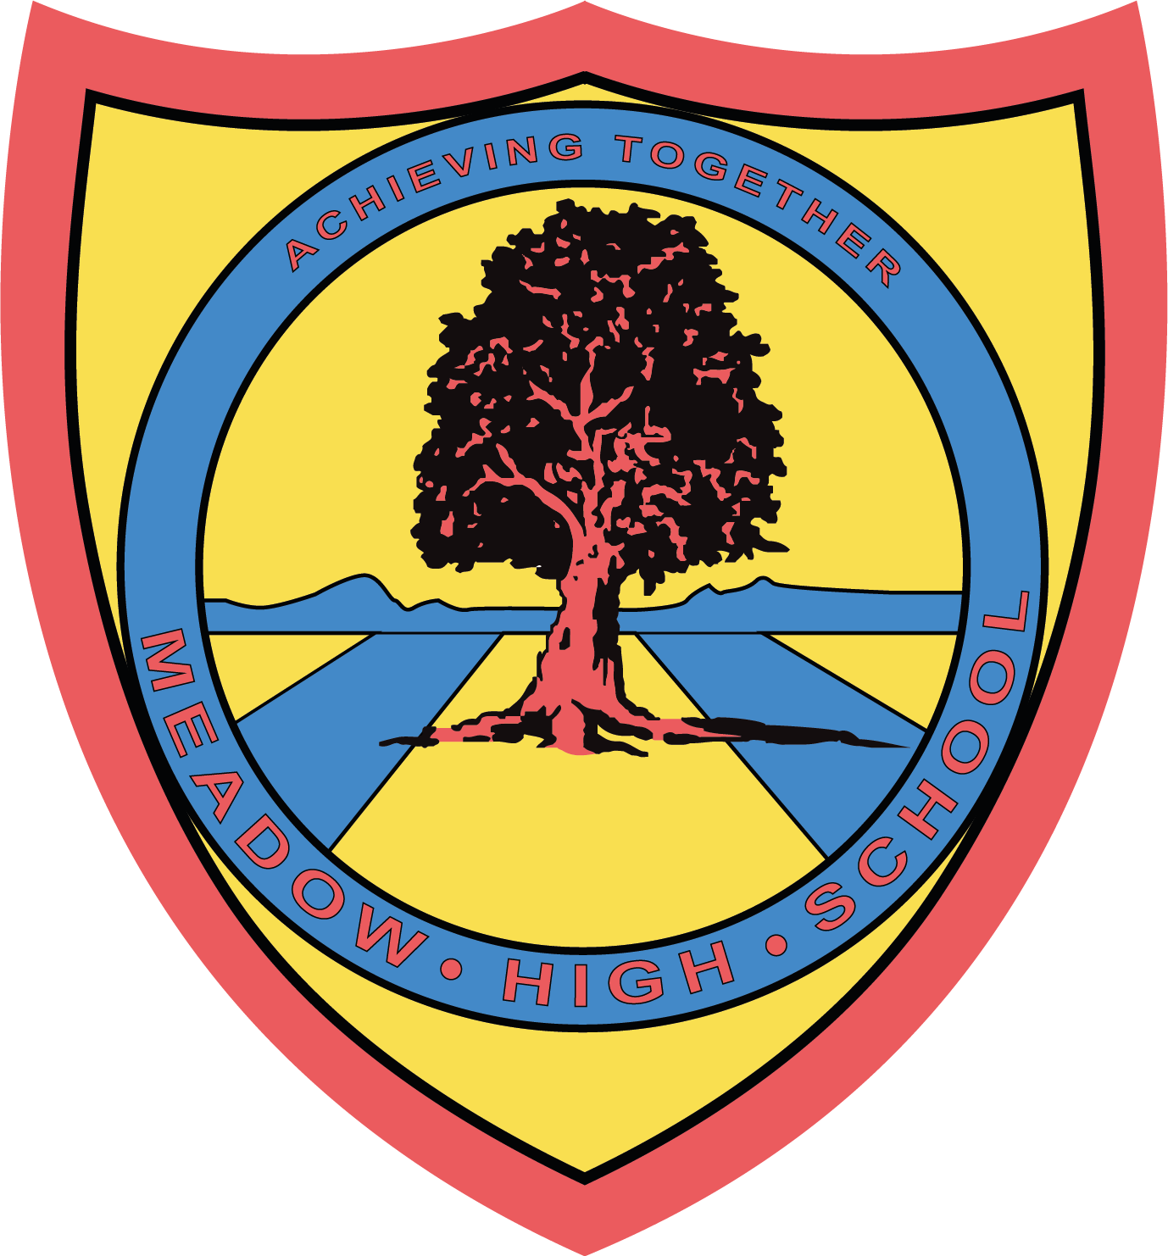

10th September 2025

Re: Swimming Lessons for year 7 students
Dear Parents / Carers,
Starting on Tuesday 16th September your child will be having their swimming lessons every Tuesday period 2 and 3, instead of PE.
These lessons are conducted off site and students will be taken there via school mini bus. Swimming lessons will be taken by a teacher from Meadow who is qualified to teach swimming lessons. They will run until the end of the Autumn term (Christmas holidays).
They will need to bring:
- Swimming trunks / costume (no bikinis)
- A towel
- Goggles if required
If you have any queries, please do not hesitate to contact me at school.
Yours Sincerely,
Ms C Sojka
(Swim Teacher)

Article 23:- 'A child with a disability has the right to live a full and decent life with dignity and independence, and to play an active part in the community.


