Meadow High School
Royal Lane, Hillingdon, Middlesex UB8 3QU

Telephone: (01895) 443310
Email: meadow@meadowhighschool.org
Website: www.meadowhighschool.org

Headteacher: Mrs Jenny Rigby
Deputy Headteacher: Ms Claire Caddell
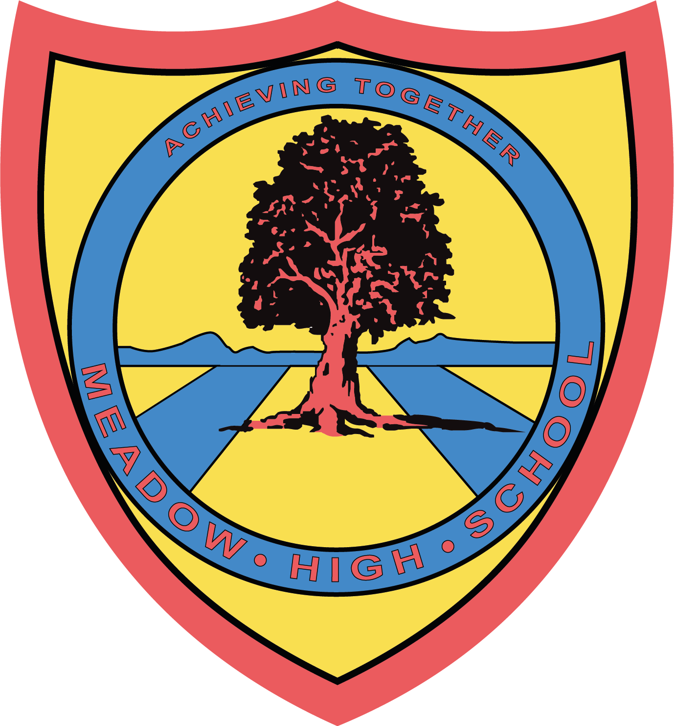

Dear Parent / Carer,

On Friday 23rd June, our Skittles club will be hosting an extra special Inclusion and Diversity Day, and we would love you to join us in our celebrations!

Skittles club is a group of students and staff at Meadow who work together to promote equality for all people in our school. We want to show that Meadow High School supports and accepts everyone. Our Inclusion and Diversity Day is an opportunity for our school community to come together and celebrate the rich and diverse backgrounds we all have!

On the day, there will be games and activities to take part in, and Skittles club will lead a parade around the school. Skittles club will also have a table selling handmade gifts and goodies to fundraise for the charity Diversity Role Models. Refreshments will be available to purchase on the day.

There will be representatives from the following organisations joining us on the day:

- The Greater London Authority
- The London Borough of Hillingdon’s Families Information Service
- Hillingdon Parent Carers Forum
- Diversity Role Models
- Volunteering Matters
- Rocket Science

We will also be joined by Metropolitan Police officers who will be bringing some of their police horses for our students to meet!

If you would like to join us on Friday 23rd June, please arrive at school at 1.45pm where a member of staff will greet you at reception. Please note that there will be no on-site parking on the day.

If you would like any further information, please contact our Librarian and Events Coordinator, Miss Gaafar, at sgaafar@meadowhighschool.org.

We look forward to seeing you there!

Kind regards,

Miss S Gaafar & Mrs C Mitchell

Article 23:- 'A child with a disability has the right to live a full and decent life with dignity and independence, and to play an active part in the community.'



