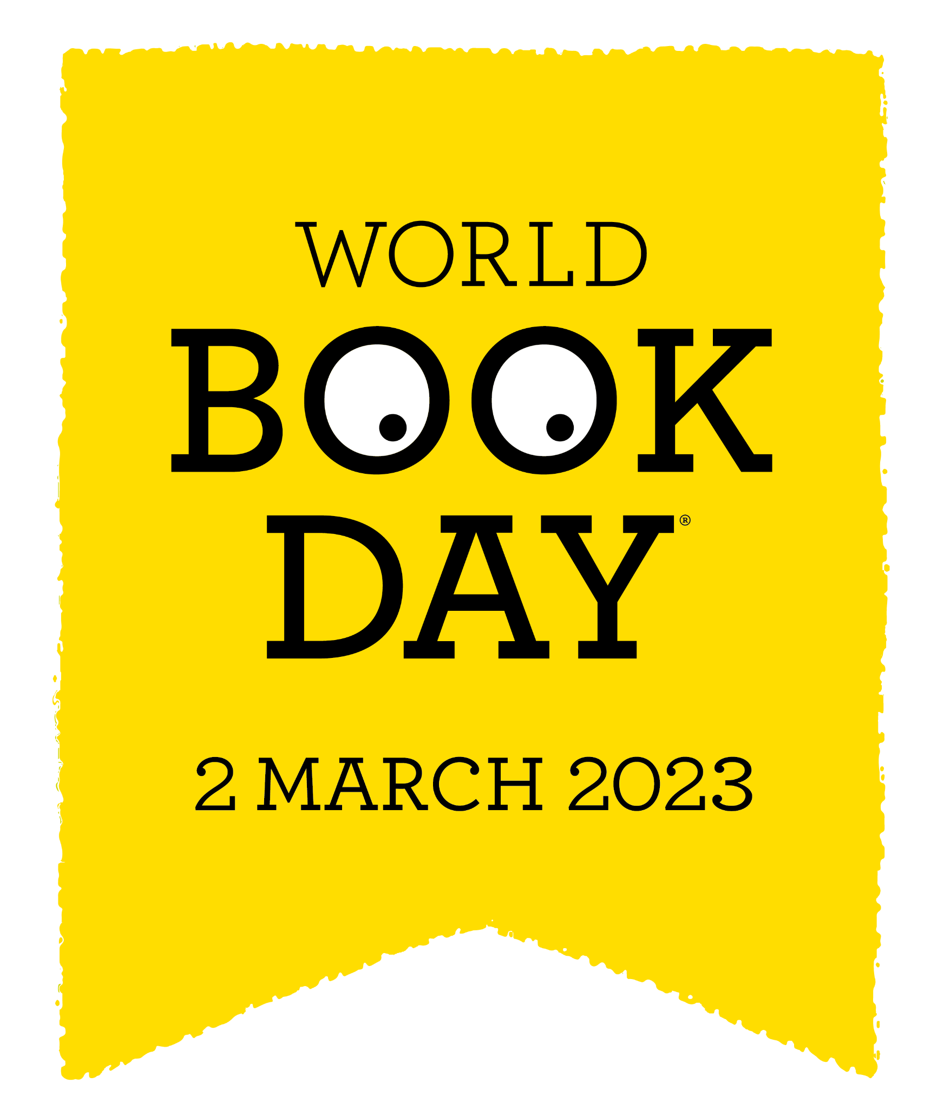

Meadow High School
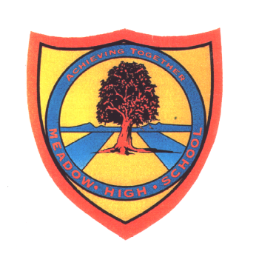
Royal Lane, Hillingdon, Middlesex UB8 3QU

Telephone: (01895) 443310
Email: meadow@meadowhighschool.org
Website: www.meadowhighschool.org

Headteacher: Mrs Jenny Rigby
Deputy Headteacher: Ms Claire Caddell

Dear Parents/Carers, 10th February 2023

Re: World Book Day Week of Activities: Monday 27th February – Friday 3rd March 2023
Literacy Across the Curriculum theme – ‘Transport – Back to the Future’

World Book Day is approaching and, as always, we are looking to use this as an opportunity to promote core literacy skills and build links with the world beyond school. World Book Day was created in 1995 by UNESCO (United Nations Educational, Science and Cultural Organisation) on Shakespeare’s birthday, 23rd April. It is now celebrated in over 100 countries around the world!

In the spirit of the UNESCO vision, this year we are teaming up with the Technology Faculty so that we can give our students a boost with their STEM subject knowledge. The theme is ‘Transport – Back to the Future’. We are also celebrating our library reopening. During the week students will have an opportunity to


- take part in a competition - draw or make a model of what they think transport will look like in the future*
- follow instructions to make a model vehicle linking forces and movement
– the BIG Car Race on Friday afternoon!
- have fun with science experiments that explore forces
- visit our library to read the new transport books we have bought
- and to spend their World Book Day voucher – we have found a company who are going to deliver the FREE world book day books to the school.
- We will also be screening showings of Back to the Future and Chitty Chitty Bang Bang
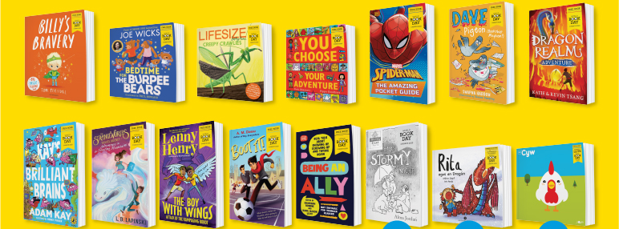

* Future Transport competition – What do you think transport will look like in the future?
Draw your idea OR make a model. Students can start work on this competition over half term if they wish. They will also have time to work on this during the first week back. (To support this work, there is a PowerPoint to explore with your child on our website.)

There will be a non-uniform/dress-up day on Friday 3rd March 2023. Students will be able to come to school dressed as either a character from a favourite story [book, film or television series], a person from a non-fiction book or anything linked to the world of work and jobs related to transport.

Yours faithfully,

Mrs. Sugden Miss Sojka Mrs. Shukla Miss Gafaar
on behalf of the EAL & Reading Intervention on behalf of the MHS Librarian
English & Communication Faculty Technology Faculty

