Meadow High School
Royal Lane, Hillingdon, Middlesex UB8 3QU

Telephone: (01895) 443310
Email: meadow@meadowhighschool.org
Website: www.meadowhighschool.org

Headteacher: Mrs Jenny Rigby
Deputy Headteacher PW2/3: Ms Claire Caddell
Deputy Headteacher PW1: Miss Amy Willis
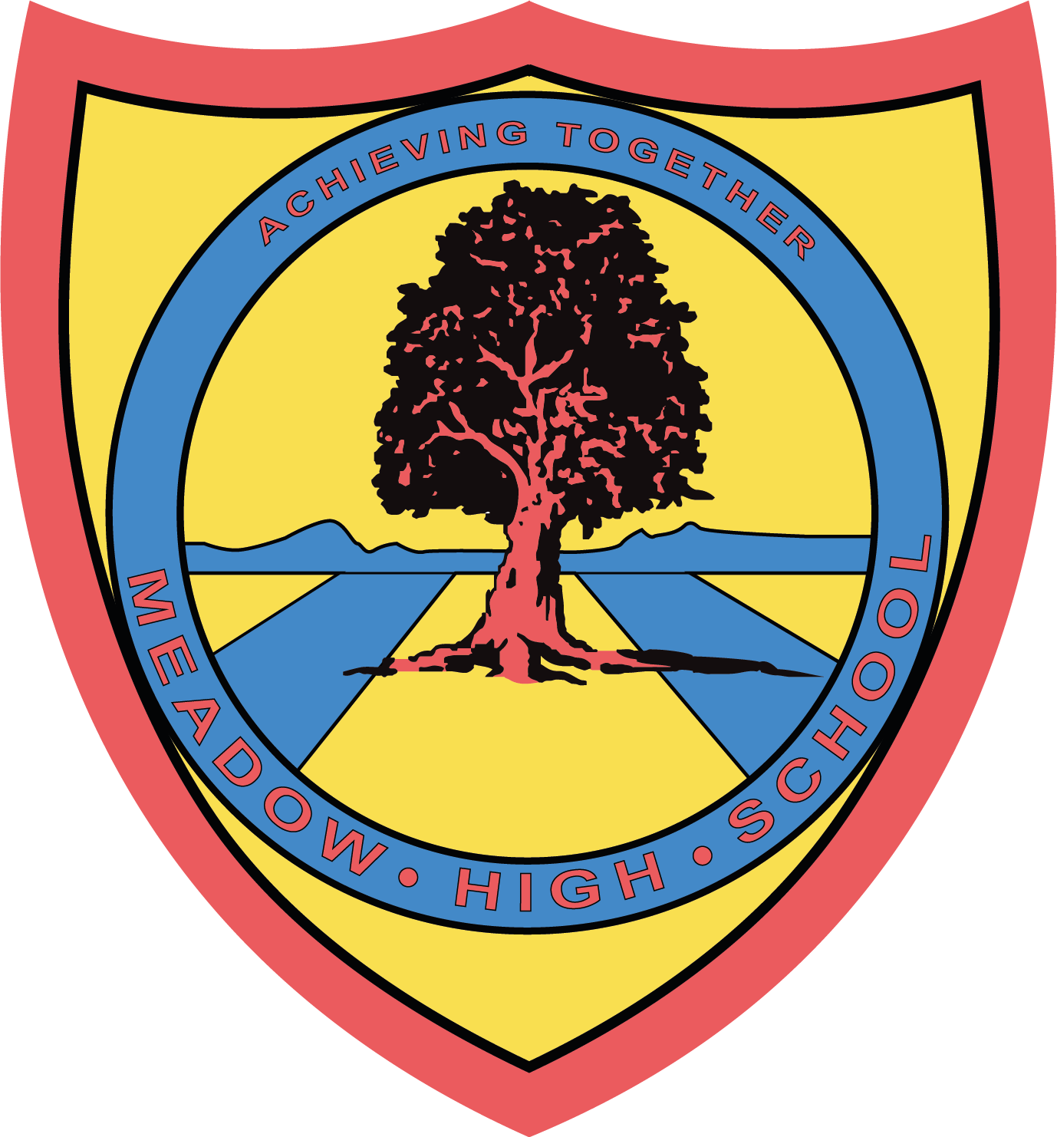

5th February 2024

Dear Parents/Carers,

Following some recent changes in the school's staffing, I will no longer be the form tutor for 10LC. I will still be working at Meadow as the Design Technology Teacher and will be closely supporting the new form tutor with your child's PLIM targets and Annual Reviews. I will be seeing the pupils daily and will continue to be available to support them should they need it.

If you have any further questions, feel free to write in your child's link book

Kind Regards,

Mr L Cowley

Article 23:- 'A child with a disability has the right to live a full and decent life with dignity and independence, and to play an active part in the community.'


