***Meadow High School***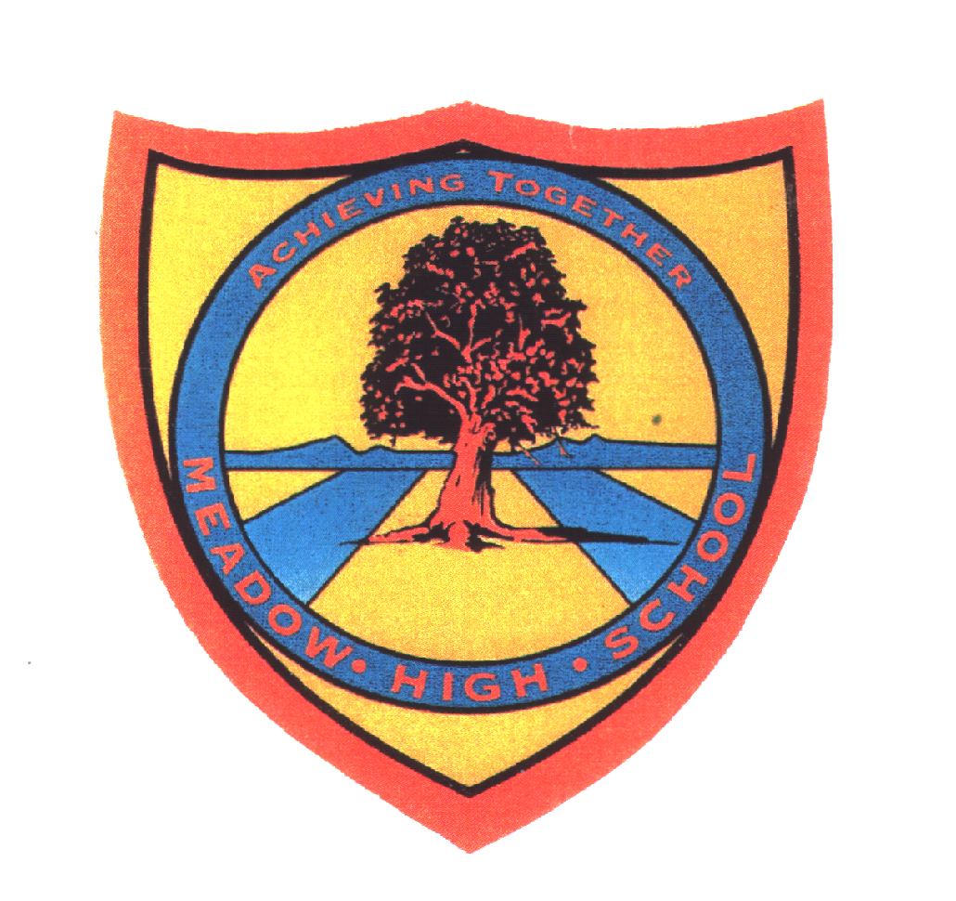

*Royal Lane, Hillingdon, Middlesex UB8 3QU*

*Telephone: (01895) 443310*

*Email: meadow@meadowhighschool.org*

*Website: www.meadowhighschool.org*

***Headteacher: Mrs Jenny Rigby***

***Deputy Headteacher: Ms Claire Caddell***

11th May 2022

Dear Parents / Carers,

**Year 11, 12, 13 and 14 Football Tournament**

Your child has signed up to play in a football tournament on **Friday 20th May.** It will be held at the school during the day. For this event, could you please make sure your child has suitable clothing and, if possible, a top to match the colour house they are in.

The pupils will be outside for large periods of the day, please make sure your child has plenty of water and sun cream with them.

Kind Regards,

**Mr. C. Morgan**

**Head of PE**