Meadow High School
Royal Lane, Hillingdon, Middlesex UB8 3QU

Telephone: (01895) 443310
Email: meadow@meadowhighschool.org
Website: www.meadowhighschool.org

Headteacher: Mrs Jenny Rigby
Deputy Headteacher (Royal Lane): Miss Michelle Taylor
Deputy Headteacher (Northwood Road): Miss Amy Willis
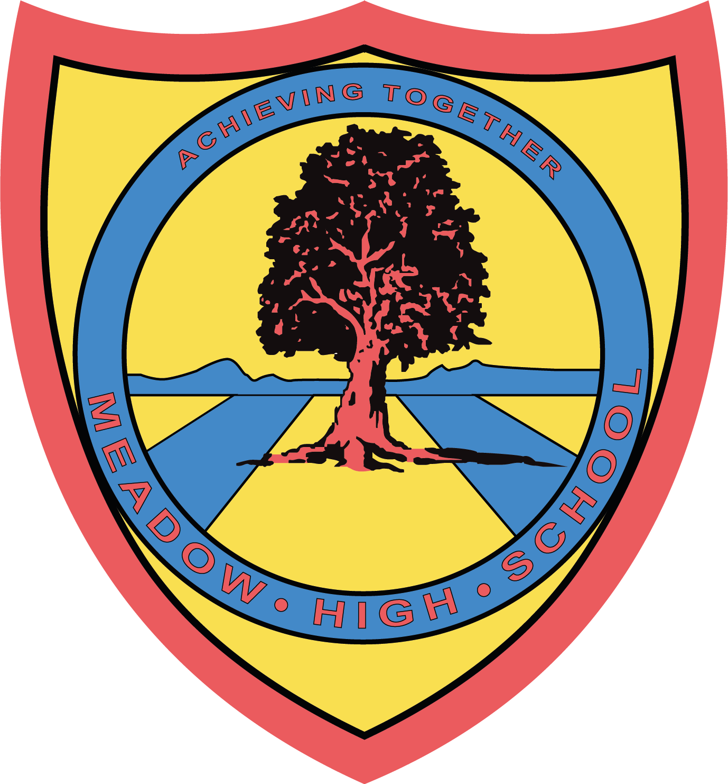

6th November 2024

Anti-Bullying Week
Odd Socks Day
Tuesday 12th November 2024

Dear Parents/Carers,
We will be celebrating our uniqueness as part of Anti Bullying Week by wearing odd socks on Tuesday 12th November 2024.
All students need to do is choose some socks that are going to be noticed - they need to be mismatched.
This is NOT a non-uniform day, so please send your child in their full school uniform, ensuring that they show off their sock choice!
https://anti-bullyingalliance.org.uk/anti-bullying-week-2024-choose-respect
Please follow the link above if you would like to learn more about Odd Socks Day and Anti Bullying Week.
Yours sincerely,

Ms Sohun
Assistant Headteacher Years 9-11

