Meadow High School
Royal Lane, Hillingdon, Middlesex UB8 3QU

Telephone: (01895) 443310
Email: meadow@meadowhighschool.org
Website: www.meadowhighschool.org

Headteacher: Mrs Jenny Rigby
Deputy Headteacher (Royal Lane): Miss Michelle Taylor
Deputy Headteacher (Northwood Road): Miss Amy Willis
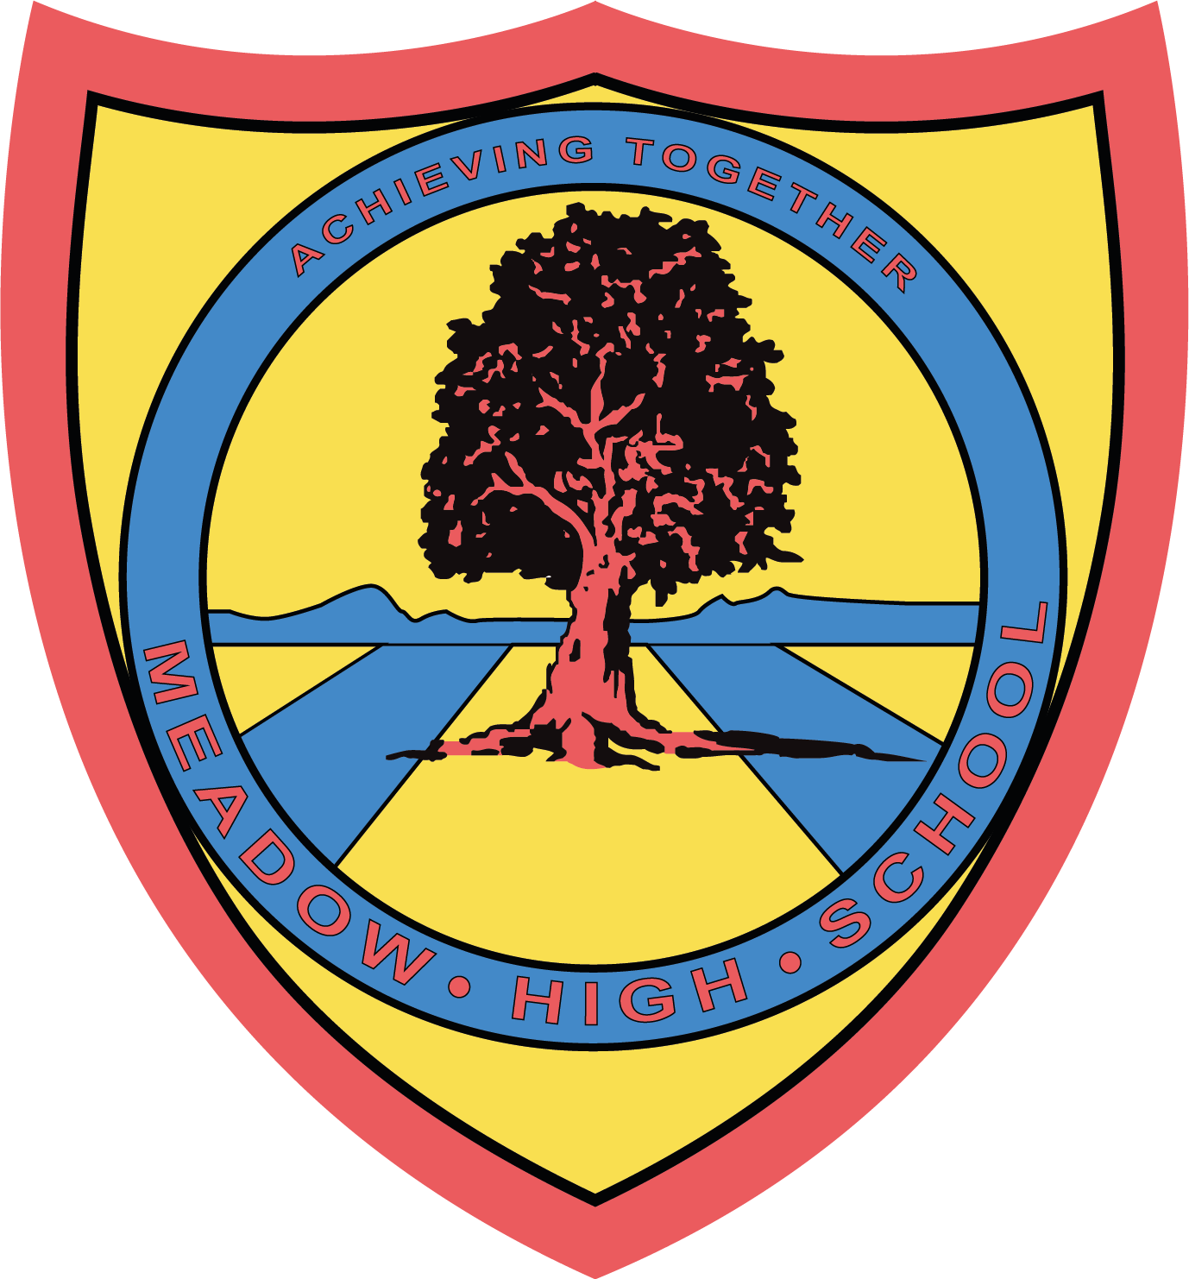

14 October 2024

Dear Parent / Carer,

On Friday 25th October, the Sixth Form Committee will be holding their first fund raising event for their chosen charity, Young Minds. Young Minds is a remarkable organisation fighting for a world where no young person feels alone with their mental health.

The Sixth Form Committee will be raising money for Young Minds by holding a cake sale at break time. We need your support by donating cakes that the committee can sell to the school community. Not only will we raising money for an excellent charity, but it will also be a good opportunity for the committee to further develop key skills and gain experience in organizing an event.

Thank you in advance,

Kind Regards

Sixth Form Committee

Article 23:- 'A child with a disability has the right to live a full and decent life with dignity and independence, and to play an active part in the community.'



