Meadow High School
Royal Lane, Hillingdon, Middlesex UB8 3QU

Telephone: (01895) 443310
Email: meadow@meadowhighschool.org
Website: www.meadowhighschool.org

Headteacher: Mrs Jenny Rigby
Deputy Headteacher (Royal Lane): Miss Michelle Taylor
Deputy Headteacher (Northwood Road): Miss Amy Willis
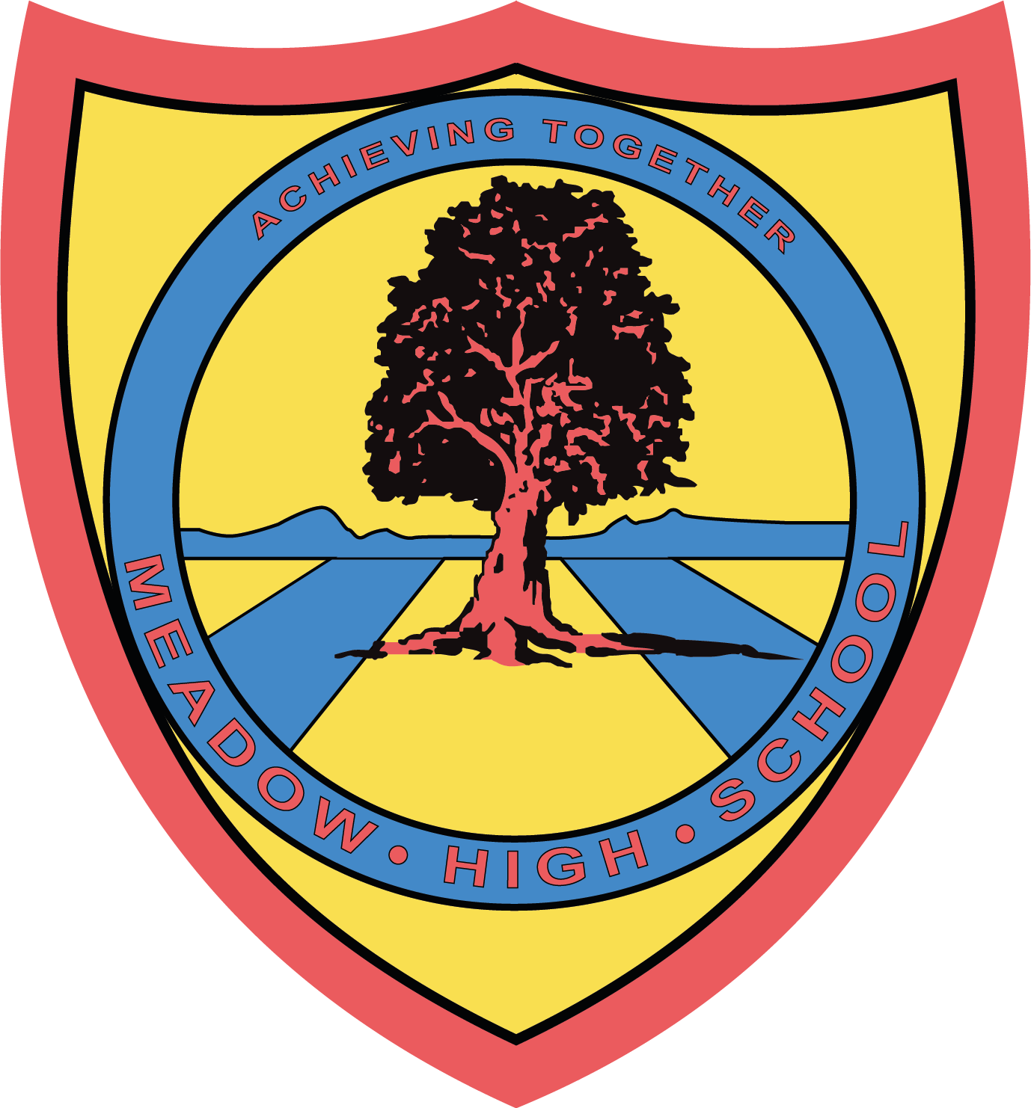

Wednesday 5th March 2025

Comic Relief / Red Nose Day
Friday 21st March 2025



Dear Parent/Carer,
On Friday 21st March, we will celebrate 40 years of Comic Relief by hosting a non-uniform day with an '80s throwback theme! If your child would prefer, they may wear red.

The pupils will be learning about the charity and all the work they do across the world in assemblies and PSHCE lessons that week. There will be a 80s themed disco run at lunchtime for all students to enjoy the iconic music and style of the decade!

We will be accepting voluntary charity donations via your child’s parent pay account.

Many thanks for your continued support.

Mrs Mistry
Assistant Headteacher Workforce Development

Article 23:- 'A child with a disability has the right to live a full and decent life with dignity and independence, and to play an active part in the community.'



