Meadow High School
Royal Lane, Hillingdon, Middlesex UB8 3QU

Telephone: (01895) 443310
Email: meadow@meadowhighschool.org
Website: www.meadowhighschool.org

Headteacher: Mrs Jenny Rigby
Deputy Headteacher (Royal Lane): Miss Michelle Taylor
Deputy Headteacher (Northwood Road): Miss Amy Willis
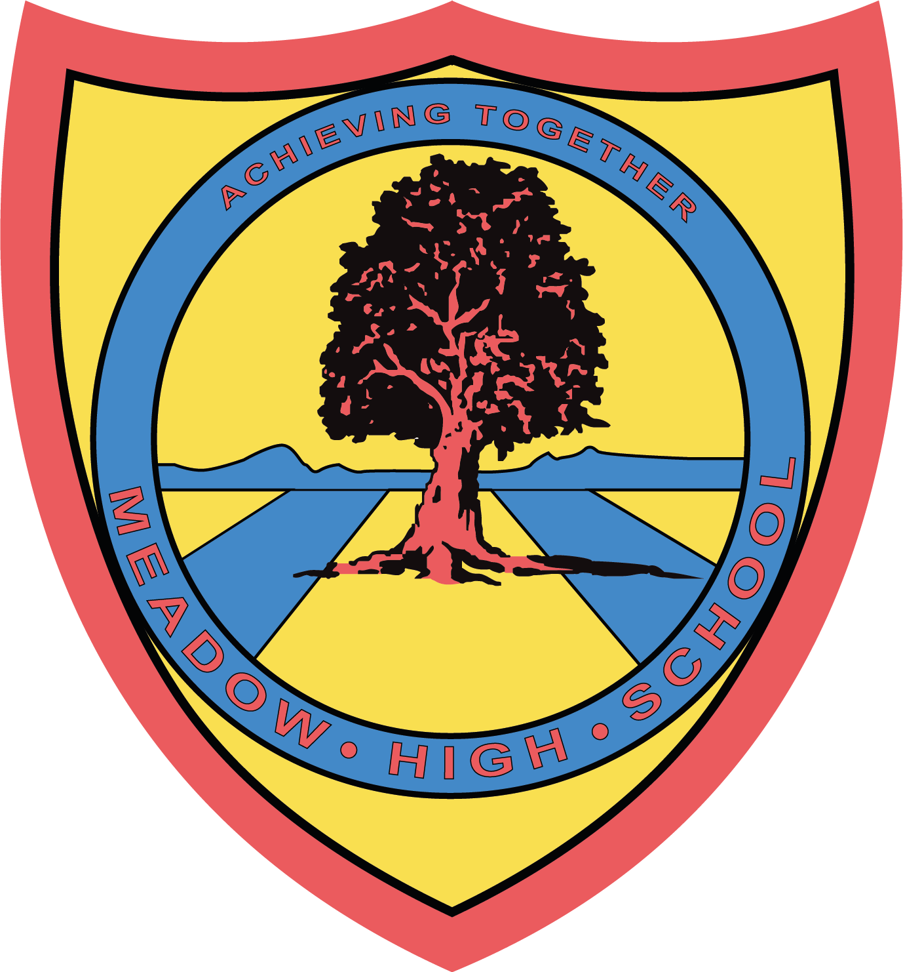

6 June 2025
Dear Parents / Carers,

Re: Leavers assembly

As you are aware, the leavers’ school year will come to an end on 27th June 2025.

We wish to invite you to our Leavers Assembly, which will take place on Friday, 27th June 27th at 11.30am.

Please see the schedule below:

11.30 - 12.15 Leavers Assembly; parents/carers to leave by 12.30 at the latest
12.15 - 12.45 Book signing / tutor based
12.45 - 13.05 Normal lunch break
13.05 - 14.30 6th Form BBQ

The school is no longer able to provide leavers' T-shirts; however, your child is welcome to bring their own if they would like it to be signed.

Please note that your child is required to contribute £2 towards the BBQ if they wish to take part. Alternatively, they are welcome to bring a packed lunch or have a school meal as usual. If your child is entitled to Free School Meals (FSM), the £2 contribution is not required.

Please see dates of other events happening this academic year:
- Pathway 2 Brighton Leavers Trip - 24th June
- Pathway 1 Chessington Leavers Trip - 26th June
- Prom - 10th July - your child will be invited to attend the Prom

We look forward to seeing you to celebrate your young person's next steps in life beyond Meadow.

Best wishes,

Mrs. A.J Fabisch Miss F Bonnar
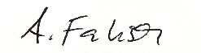
Head of 6th Form (F) Assistant Headteacher PW1
afabisch@meadowhighschool.org

Please return the attached reply slip to your child’s form tutor by 13th June 2025. Thank you
--------------------------------------------------------------------------------------------------------------
Student’s name: ______________________________________________________________________________

I would like my child to take part in the BBQ and agree to contribute £2 towards it by 20th June 2025 YES/ NO

I would like my child who is entitled to FSM to take part in the BBQ YES/ NO

I would like my child to have the school meal as usual instead YES/ NO

My child will bring a packed lunch on the day YES/ NO

Parent’s / Carer’s signature: _________________________________________________________________

