Meadow High School
Royal Lane, Hillingdon, Middlesex UB8 3QU

Telephone: (01895) 443310
Email: meadow@meadowhighschool.org
Website: www.meadowhighschool.org

Headteacher: Mrs Jenny Rigby
Deputy Headteacher PW2/3: Ms Claire Caddell
Deputy Headteacher PW1: Miss Amy Willis
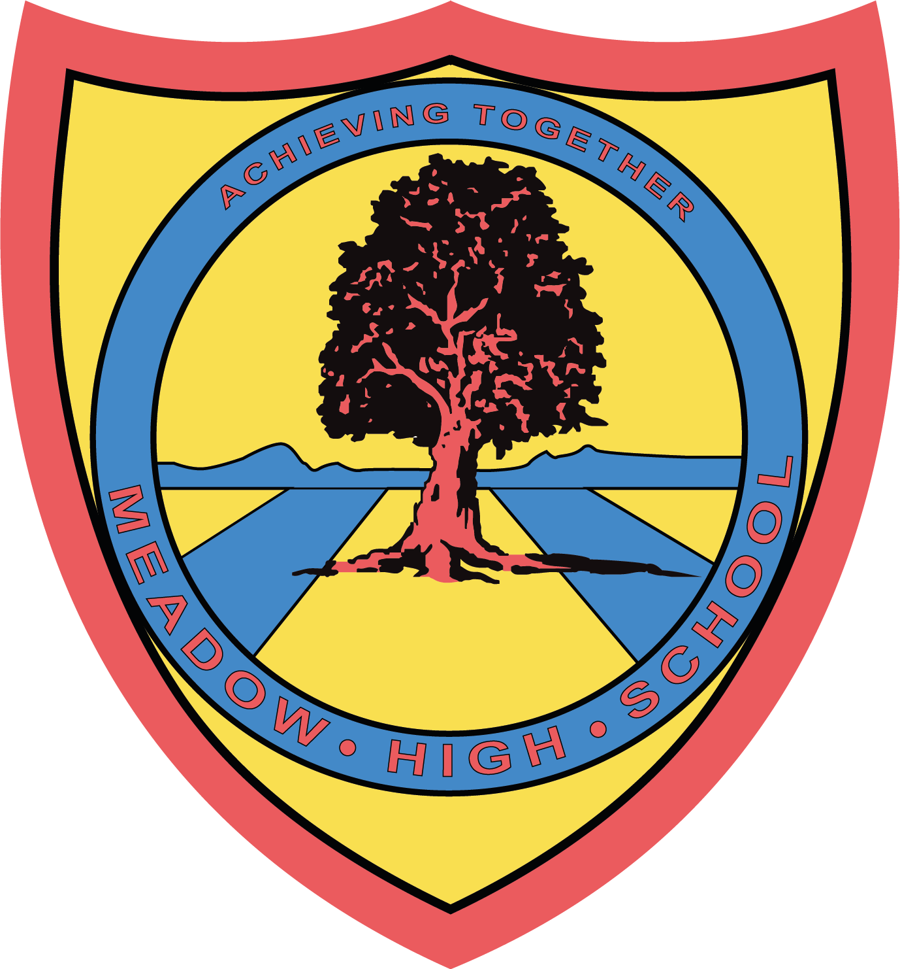

February 2024
Dear Parents/Carers,

Pupils in Miss Robinson’s class have been working towards their Bronze Duke of Edinburgh Award. To achieve the full award pupils are required to undertake a 2 day, 1 night expedition.

On 4th-5th July 2024, it has been arranged for the class to complete the expedition at Rickmansworth Canoe Sports Trust, with two days undertaking water sports, including canoeing and paddle boarding. Pupils will then ‘camp’ (in the classroom/field) on the Thursday night. They will also be cooking their own food for dinner on the Thursday evening.

It is a great opportunity for pupils to undertake a new challenge and push themselves and we would love it if all pupils from the class can join us. Familiar staff from school will support throughout the duration of the expedition. All pupils' needs will be discussed in advance with families to ensure everyone is supported and feeling confident to undertake the expedition.

Unfortunately, if the young people do not attend they won't achieve the full award. They will still receive their Bronze Duke of Edinburgh Award for the sections they have achieved in school, but will not achieve the full accreditation.

If you have any questions or concerns please contact fbonnar@meadowhighschool.org
Many thanks,
Faye Bonnar
Assistant Head Pathway 1

Article 23:- 'A child with a disability has the right to live a full and decent life with dignity and independence, and to play an active part in the community.'

----------------------------------------------------------------------------------------------------------------
Return slips to Miss F Bonnar or email fbonnar@meadowhighschool.org
I would like ___________________________________ (pupils name) to attend the 2 day, 1 night expedition.
I am not interested in ___________________________________ (pupils name) attending the expedition.

Signed _____________________________________ (parent/carer)

