Meadow High School

Royal Lane, Hillingdon, Middlesex UB8 3QU

Telephone: (01895) 443310 Email: meadow@meadowhighschool.org Website: www.meadowhighschool.org

Headteacher: Mrs Jenny Rigby

Deputy Headteacher: Ms Claire Caddell 28th January 2022

Dear Parents/Carers,

Meadow High School Celebrates Harry Potter Dav! Thursday 3 rd February 2022

This year is the 25th anniversary of the first publication of the book Harry Potter & the Philosopher's Stone — hard to believe I know! Therefore, to brighten a rather gloomy grey start to the year and link to Harry Potter Night, we thought it would be fun to have a Harry Potter Day.

Students and staff are invited to come to school dressed as their favourite character from the Harry Potter series or wear any Harry Potter or wizard's clothes they have — only toy cats, rats, toads, owls etc. please!

This event is free. We will set up the sorting hat in the hall at lunchtime for students wanting to find out which house they would be in at Hogwarts School.

We hope that Muggles and Wizards will both enjoy the day!

Yours faithfully,

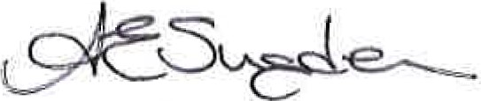

Anne Sugden

(on behalf of all Harry Potter fans - staff and students!)

English & Communication Faculty Leader

|  |  |  |  |  |
| --- | --- | --- | --- | --- |
|  | |  | | --- | | ssat | |  | |  |

 Widgit Scouts — MEADOW

HIGH SCHOOL a'î-xŽ2 SEN SPECIAL" CENTRE-S 8th Scout Group 

SCHOOLS