Meadow High School
Royal Lane, Hillingdon, Middlesex UB8 3QU

Telephone: (01895) 443310
Email: meadow@meadowhighschool.org
Website: www.meadowhighschool.org

Headteacher: Mrs Jenny Rigby
Deputy Headteacher PW2/3: Ms Claire Caddell
Deputy Headteacher PW1: Miss Amy Willis
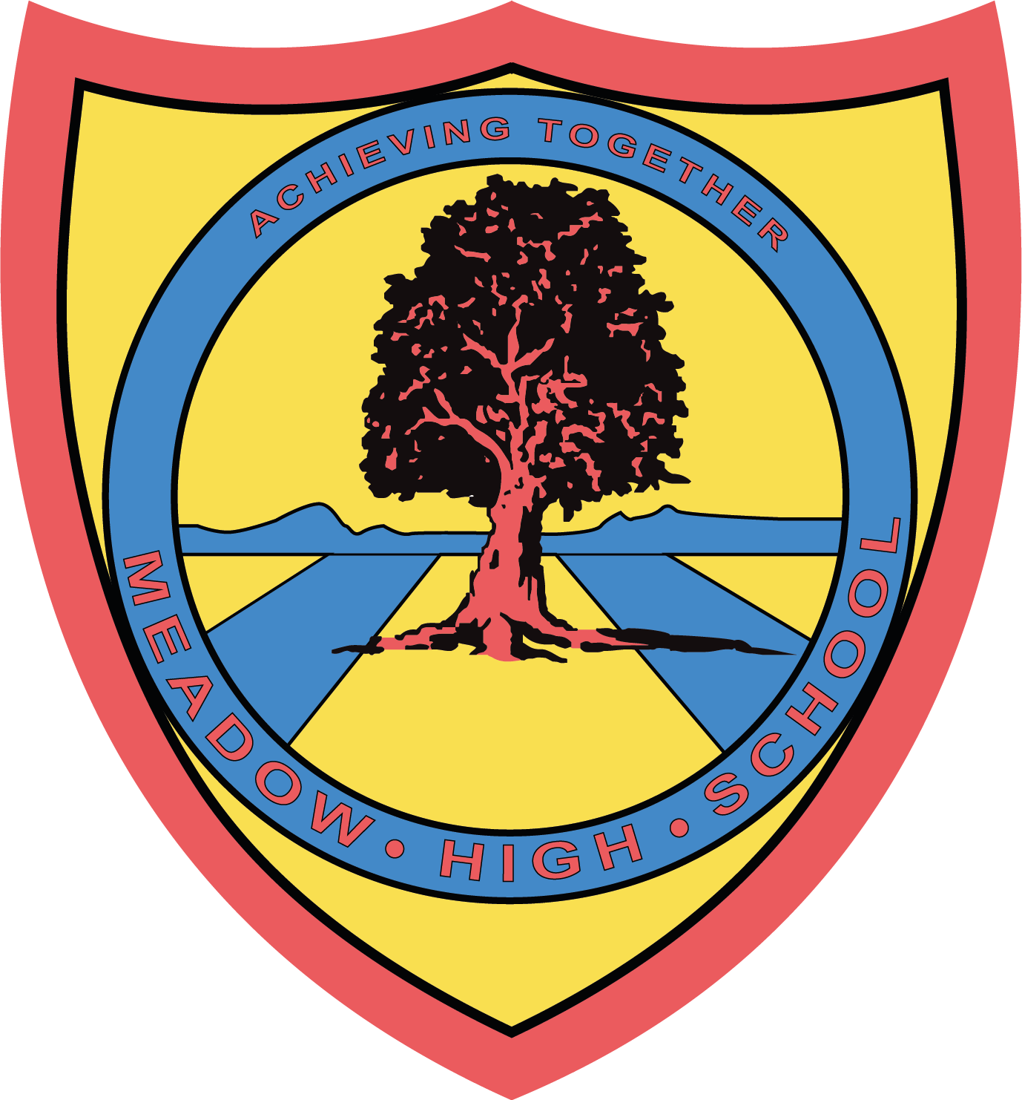

April 2024

Dear Parent/Carer,

In Food Technology, we will be focusing on independent cooking. We will focus on Health and Safety within a kitchen and cooking everyday meals to learn new skills. There will be a combination of taste testing, evaluation of products as well as practical lessons.

If you wish your child to take home the products that they have prepared, the amount required for the practical and taste testing lessons will be £10.00.

In order to save administration time, we would like the termly cost of your child’s Food Technology practical work to be paid all at once via ParentPay.

If you require any assistance with your Parent Pay account, please contact the school reception for support.

Thank you in advance.

Yours faithfully,

Mrs P. Shukla
Food Technology Teacher

Article 23:- 'A child with a disability has the right to live a full and decent life with dignity and independence, and to play an active part in the community.'


