KS3 ICT Cycle 1 Summer
Use of Ipads

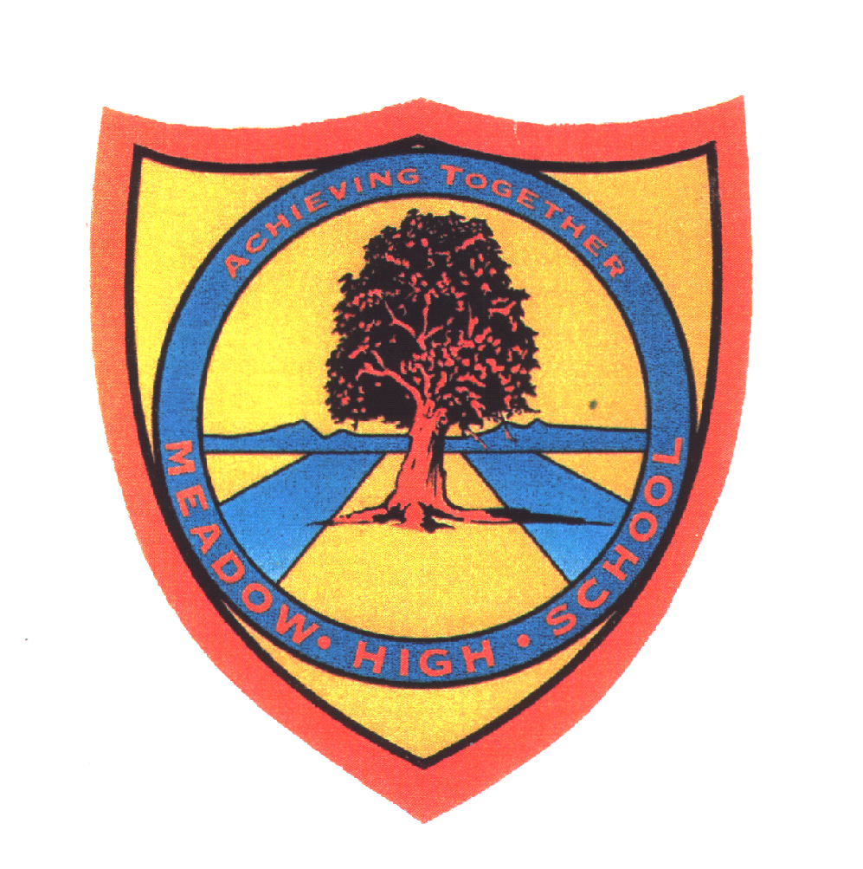 | Pathway 1 | Cycle 1  KS 3 (Pathway 1) | Term Summer
Learning Intention: This SOW aims to teach the pupils how to take photos, record a video, search for information, have fun and learn using an Ipad. In the end, the pupils will be able to perform basic functions on an Ipad without adult support. Some pupils will be able to download educational and entertaining applications to reinforce their learning and support their wellbeing.
Key knowledge that should be learned during this SoW |  | All | Most | Some
Concept: |  | The pupils will understand Ipad related concepts such as on, off, log into and lock it. | In addition to the previous, the pupils will understand the concepts of editing, recording and searching. | In addition to the previous, the pupils will understand the concept of transferring information from the Ipads to the computers.
Knowledge: |  | The pupils will learn what Ipads are used for. | The pupils will learn what Ipads are used for and be able to explain. | In addition to the previous, some pupils will learn that information can be transferred from an Ipad to a computer.
Key Skills: |  | The pupils will learn how to turn an Ipad on and off and how to log into it and lock it in the end. | In addition to the previous, the pupils will learn how to take good photos using the Ipads. They will learn how to record a good video. They will also learn how to search for information on the Internet using an Ipad. | In addition to the previous, the pupils will learn how to download new applications on an Ipad and how to transfer information from an Ipad to a computer.
Language and/or communication skills: |  | The pupils will learn to communicate while take a photo using an Ipad. They will also use their language skills to ask for permission before they take a photo. They will also be able to share their likes/dislikes using an Ipad. The pupils will learn the following keywords: on, off, log into, lock, permission, photo, Ipad. | In addition to the previous, the pupils will improve their language skills by describing the objects, places and people they are taking photos of. They will also be able to share their findings on the Internet. The pupils will learn the following keywords: on, off, log into, lock, permission, photo, Ipad, edit, record, search, video, place, object, people. | In addition to the previous, the pupils will learn to use their language skills to describe the scenery they recording using an Ipad. The pupils will learn the following keywords: on, off, log into, lock, permission, photo, Ipad, edit, record, search, video, place, object, people, transfer, application.
Curricular Links |  | Links to other learning within the subject and spiral learning links: Turn a device on and off, log into a device, or lock it, search for information on the Internet, edit photos, use of the Youtube, access to online games.  Cross-curriculum links and over learning opportunities: English: speaking and listening, typing, reading, PSHCE, Art

