Meadow High School
Royal Lane, Hillingdon, Middlesex UB8 3QU

Telephone: (01895) 443310
Email: meadow@meadowhighschool.org
Website: www.meadowhighschool.org

Headteacher: Mrs Jenny Rigby
Deputy Headteacher (Royal Lane): Miss Michelle Taylor
Deputy Headteacher (Northwood Road): Miss Amy Willis
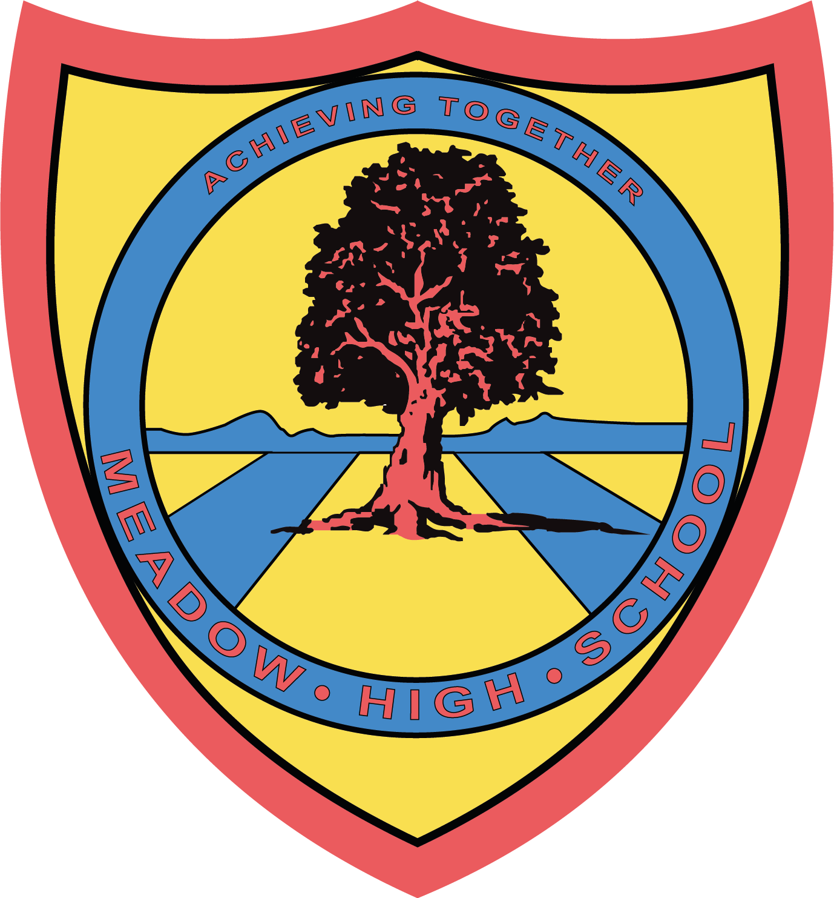

Thursday 15th May 2025

Dear Parent/Carer,

Trip to Mission EmployAble Community Cafe – Thursday 22nd May 2025

As part of your child’s Vocational Studies programme, I have organised a visit to the Mission EmployAble Community Café in Chorleywood on Thursday 22nd May 2025.

We will depart school at 9:50am, following Lesson 1, and return in time for lunch at 12:45pm. Transport will be provided via the school minibus, which will be driven by a fully qualified MIDAS-trained driver. A designated First Aider will also be accompanying the group.

During the visit, students will explore the structure and daily operations of a community café, as well as gain insight into the various roles involved and how supported internships work in such a setting.

Students will also have the opportunity to purchase a snack and a drink from the café. If they would like to do so, please ensure they bring a small amount of spending money.

If you have any questions or require further information, please do not hesitate to contact me or your child’s form tutor.

Yours sincerely,

Mrs Tudor
Vocational Faculty Lead
Article 23:- 'A child with a disability has the right to live a full and decent life with dignity and independence, and to play an active part in the community.'



