Meadow High School
Royal Lane, Hillingdon, Middlesex UB8 3QU

Telephone: (01895) 443310
Email: meadow@meadowhighschool.org
Website: www.meadowhighschool.org

Headteacher: Mrs Jenny Rigby
Deputy Headteacher: Ms Claire Caddell
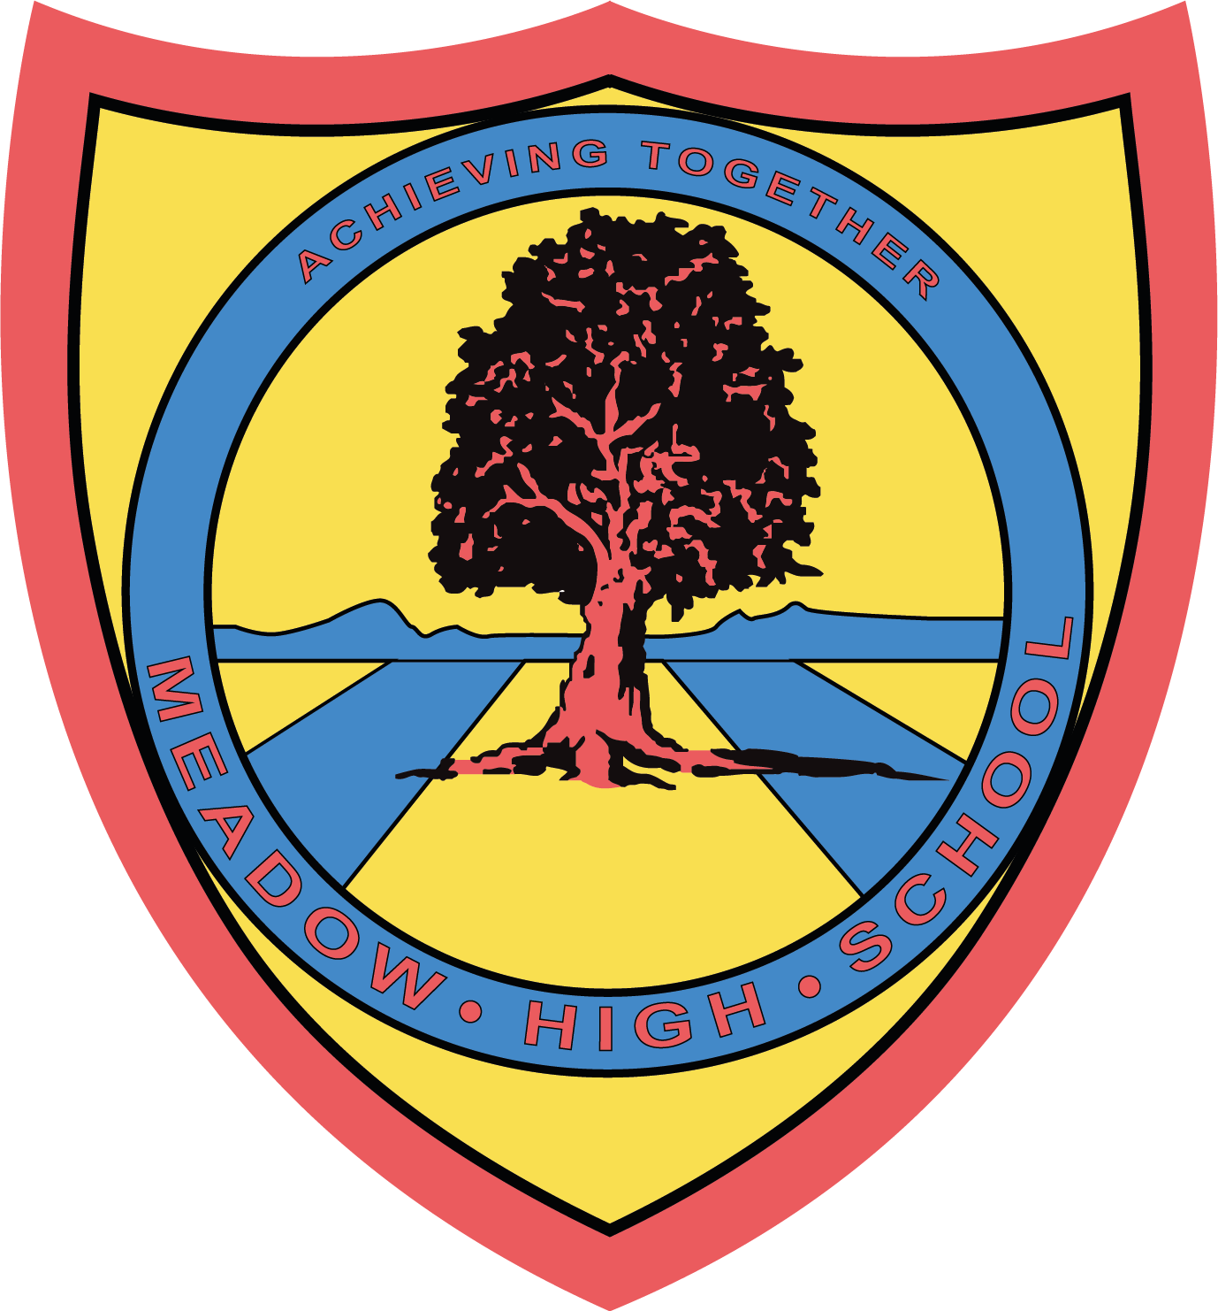

Thursday 25th May 2023

Dear Parents / Carers,
Sports Day – Pathway 1

Pathway 1 Sports Day will be taking place on Thursday 8th June.

On this day, please make sure you send your child in with their PE kit and a top to represent their house colour.

The pupils will be outside for large periods of the day, please make sure your child has plenty of water and sun cream with them.

I am pleased to announce that parents / carers will be able to attend this year to watch the races. Races will be taking place from 13:40 - 15:00. There will be NO parking on site unless you have a blue badge for personal use only. Please contact reception if you wish to reserve a parking space.

Kind regards,

Mr. Anstee
Head of PE

