Meadow High School
Royal Lane, Hillingdon, Middlesex UB8 3QU

Telephone: (01895) 443310
Email: meadow@meadowhighschool.org
Website: www.meadowhighschool.org

Headteacher: Mr Graham Cunningham
Deputy Headteacher (Royal Lane): Miss Michelle Taylor
Deputy Headteacher (Northwood Road): Miss Amy Willis
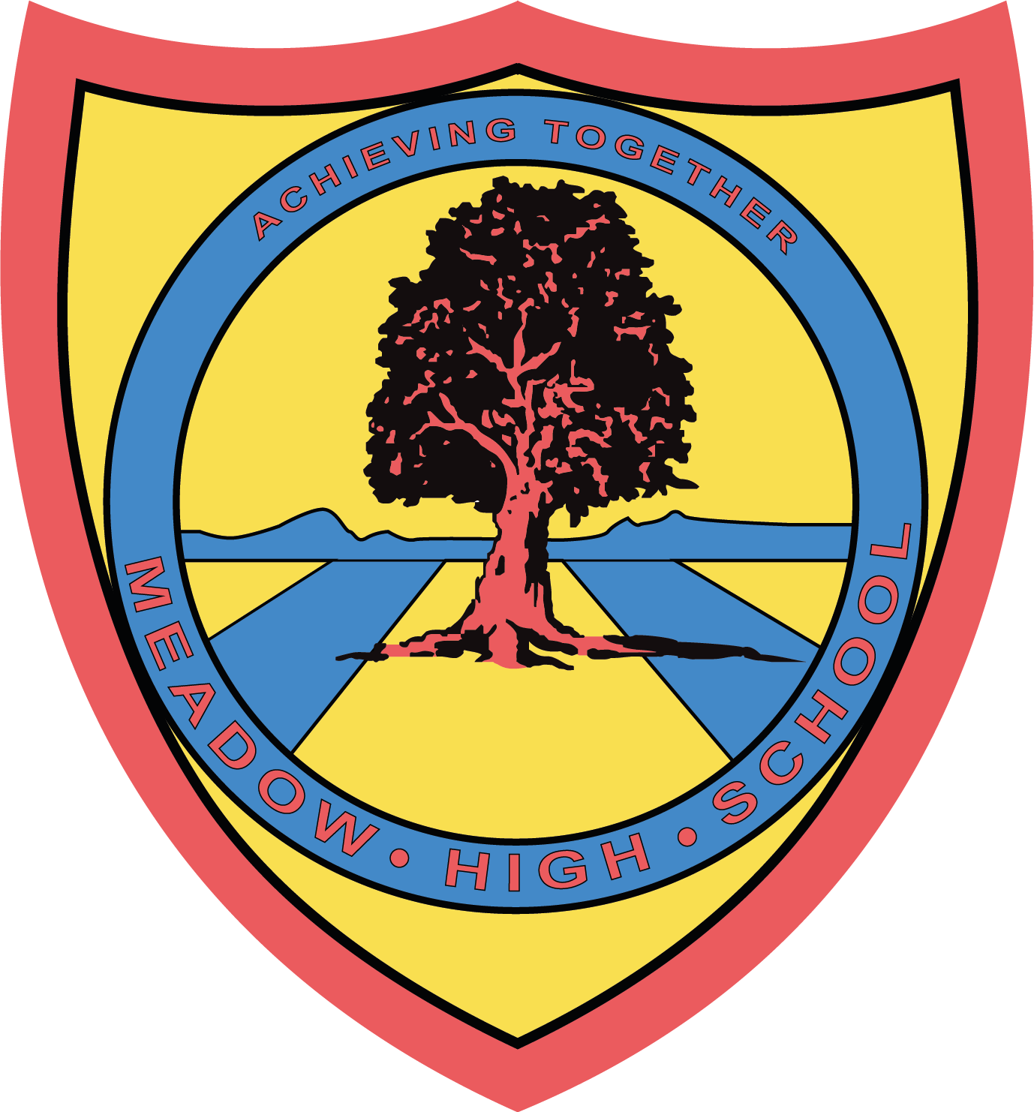

8 October 2025


Show Racism the Red Card
Wear Red Day!
Dear Parents/Carers,

On Friday 17th October 2025, our school will be taking part in an event organised by Show Racism the Red Card (SRtRC), called Wear Red Day.

On the day, pupils and staff are encouraged to wear something red to show support for anti-racism and help challenge racism in society. This could be a full red outfit or something simple like red socks or a red accessory. Please remember: no hoodies allowed.

In the lead-up to Wear Red Day, pupils will be learning about the charity, the history behind the campaign, and how they can help challenge and dismantle racism.

To take part, we kindly ask for a 50p donation, which can be paid:
- In cash on the day handed in to the class team / reception, or
- Via Parent Pay

SRtRC is the UK’s largest anti-racism educational charity. You can find more information about the organisation at www.theredcard.org.

Thank you for your continued support.

Yours sincerely,
M. Newman & C. Sojka
EDI Leads

Article 23:- 'A child with a disability has the right to live a full and decent life with dignity and independence, and to play an active part in the community.'



