Meadow High School
Royal Lane, Hillingdon, Middlesex UB8 3QU

Telephone: (01895) 443310
Email: meadow@meadowhighschool.org
Website: www.meadowhighschool.org

Headteacher: Mrs Jenny Rigby
Deputy Headteacher: Ms Claire Caddell
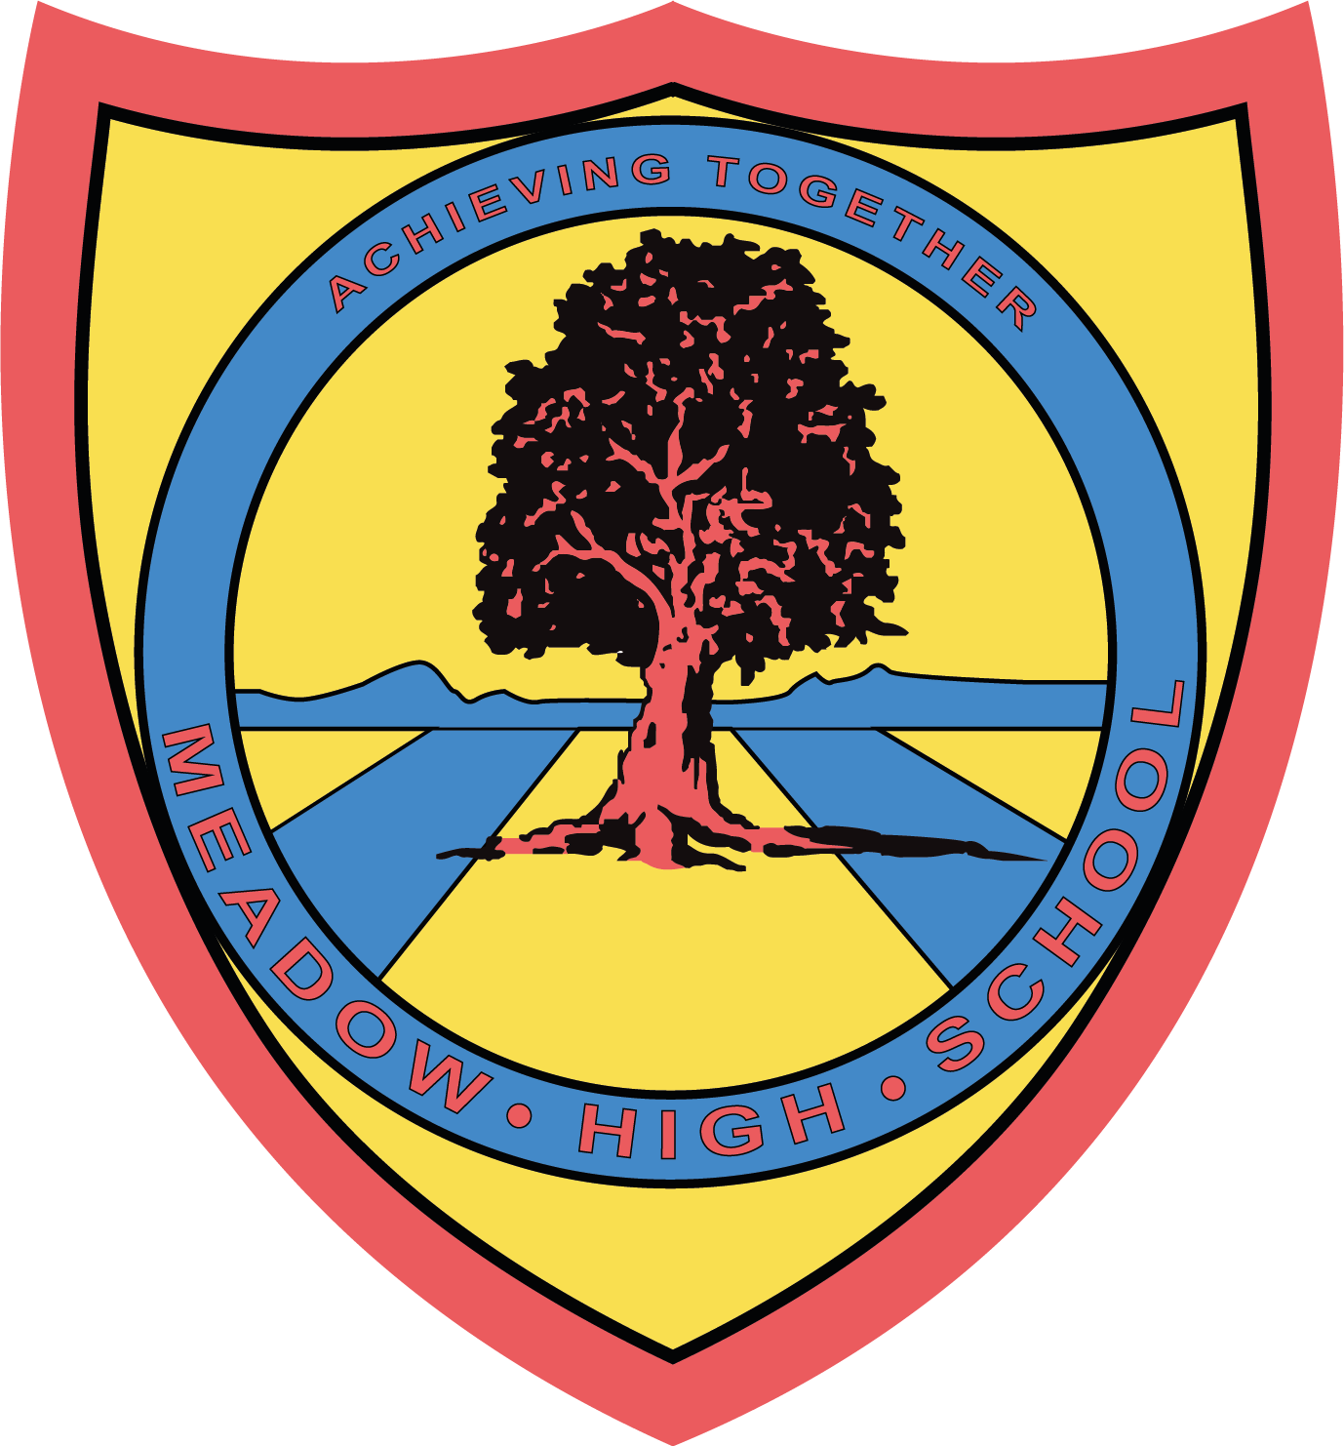

16th May 2023

Dear Parents / Carers,

Science Trip to the Natural History Museum

To support your child with their learning in Science, we have arranged an educational visit to The Natural History Museum to assist with their studies on extinction and endangered species.

The event will be taking place on Thursday 18th May 2023. We will leave school at 9:30am and return at 14:30pm in time for normal transport home. We will be travelling by school minibus and first aiders will also accompany us.

Please provide your child with a healthy packed lunch. If your child is entitled to a Free School Meal, we can provide one, please indicate below.

Please complete and return the below reply slip as soon as possible. If you have any queries, please feel free to contact me.

Kind Regards,

Miss Khan
11ZK Form Tutor

Article 23:- 'A child with a disability has the right to live a full and decent life with dignity and independence, and to play an active part in the community.'


REPLY SLIP: PSHCE trip to the Natural History Museum – please return to Miss Khan

Pupil Name: _____________________________________

My child will bringing a healthy packed lunch.

My child is entitled to a free school meals and would like a: tuna ( ) cheese ( ) egg ( )
sandwich (please tick).

Signed: ___________________________________ Date: _________________

