Meadow High School
Royal Lane, Hillingdon, Middlesex UB8 3QU

Telephone: (01895) 443310
Email: meadow@meadowhighschool.org
Website: www.meadowhighschool.org

Headteacher: Mrs Jenny Rigby
Deputy Headteacher PW2/3: Ms Claire Caddell
Deputy Headteacher PW1: Miss Amy Willis
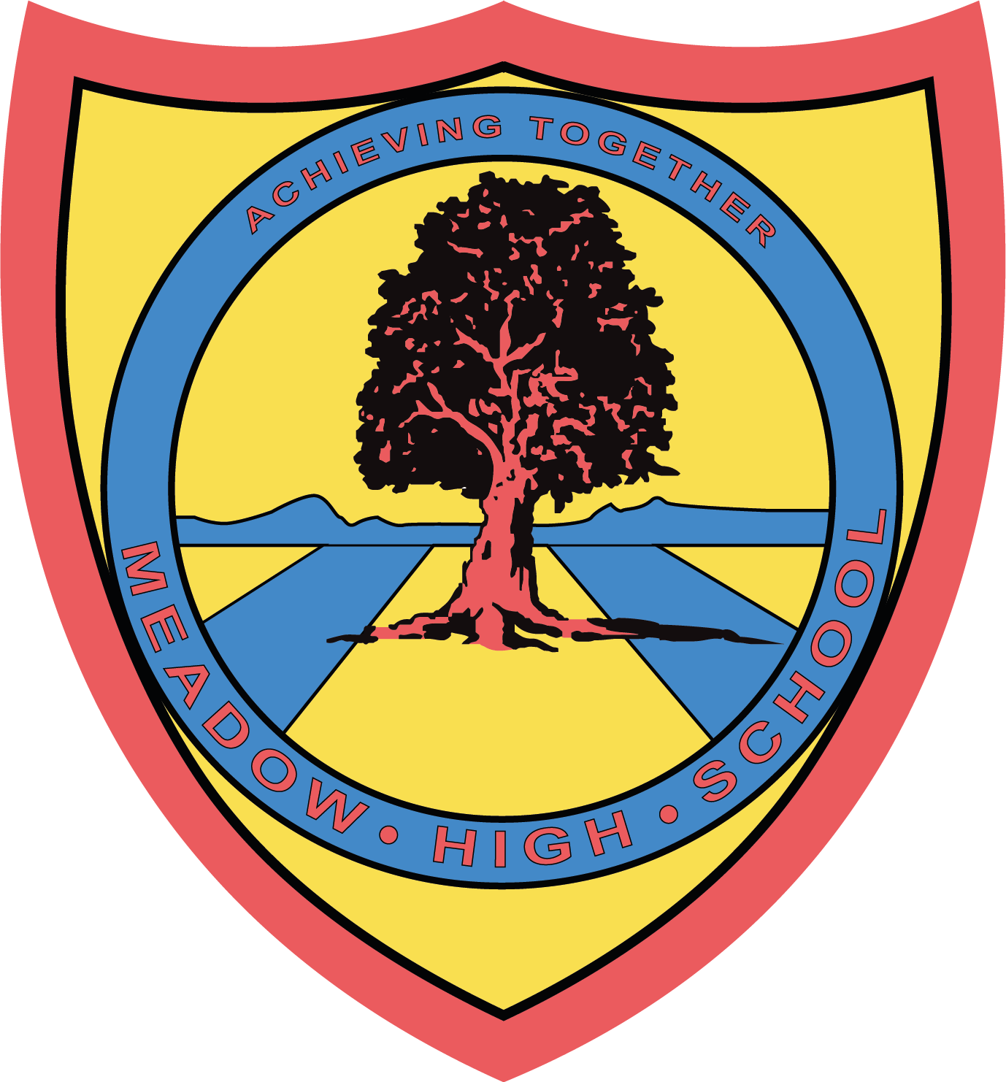

April 2024

Dear Parent/Carer,

In Food Technology this term, pupils will be building on their independent cooking skills. They will be taking part in theory as well as various practical lessons with the opportunity to learn new skills and further develop their confidence towards everyday cooking

If you wish for your child to take home the products that they prepare, the amount required for the practical lessons will be £10.00 for the term.

Please make all payments via Parent Pay.

If you are unable to make this payment in full, please contact the school office.

Thank you in advance.

Food Technology Department

Article 23:- 'A child with a disability has the right to live a full and decent life with dignity and independence, and to play an active part in the community.'


