Meadow High School
Royal Lane, Hillingdon, Middlesex UB8 3QU

Telephone: (01895) 443310
Email: meadow@meadowhighschool.org
Website: www.meadowhighschool.org

Headteacher: Mrs Jenny Rigby
Deputy Headteacher: Ms Claire Caddell
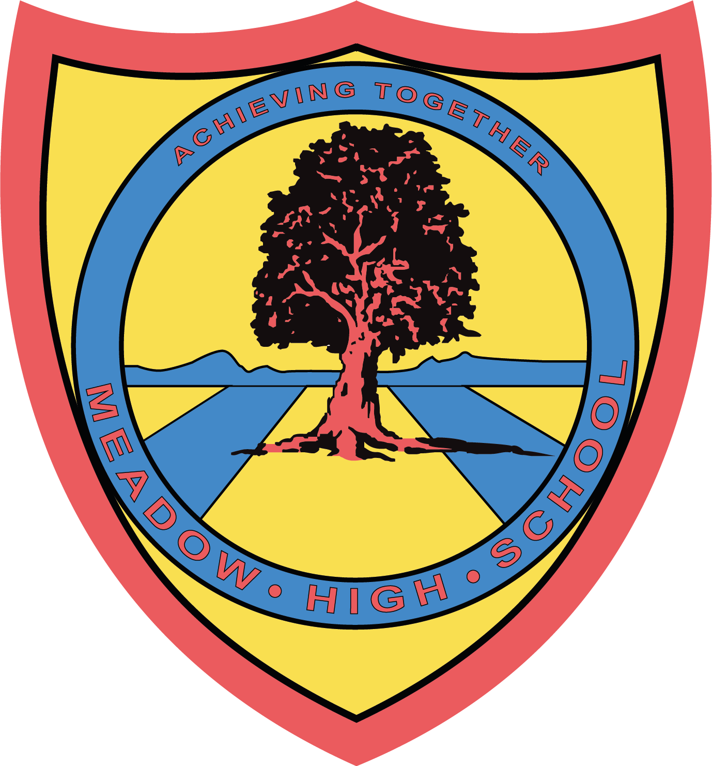

26th June 2023

Dear Parents / Carers

REMINDER - KS5 Leavers BRIGHTON TRIP – Thursday 29th June
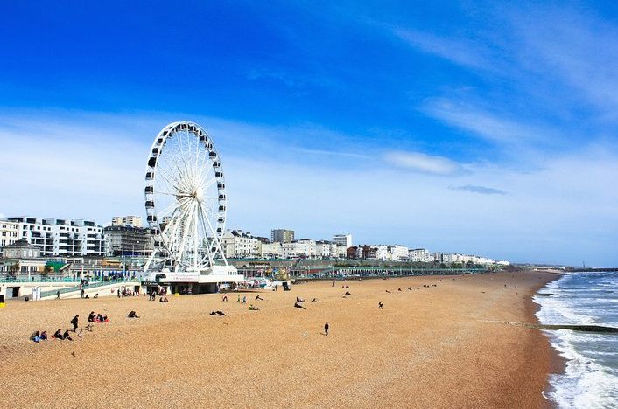
BRING:
- £15
- Sunscreen
- Rain coat (just in case!)
- Water & snacks
- Medication if necessary
Optional:
- Phone for photos / music (aeroplane mode only)

Reminder of Schedule:

9.00-9.30am Registration
9.30-11am Travel to Brighton
11.00-12.00pm Class groups walk around the beach, shops and pier with class support
12.00-1.30pm All students lunch on the beach / students to purchase fish and chips / ice-cream etc. or enjoy a packed lunch from home / school (if eligible for FSM)
1.30-3.00pm Class groups walk around the beach, shops and pier with class support
3.00-5.00pm Travel back to Meadow High School
5.00pm Parents collect onsite or students with permission travel home independently

Contact Number of the day: 07851 254258

Kind Regards,
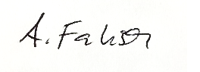
A Fabisch
Head of 6th Form

Article 23:- 'A child with a disability has the right to live a full and decent life with dignity and independence, and to play an active part in the community.'



